**GIT:**

Many people, especially beginners, may think that Git and GitHub represent the same thing, but infact Git and GitHub are two completely different things. 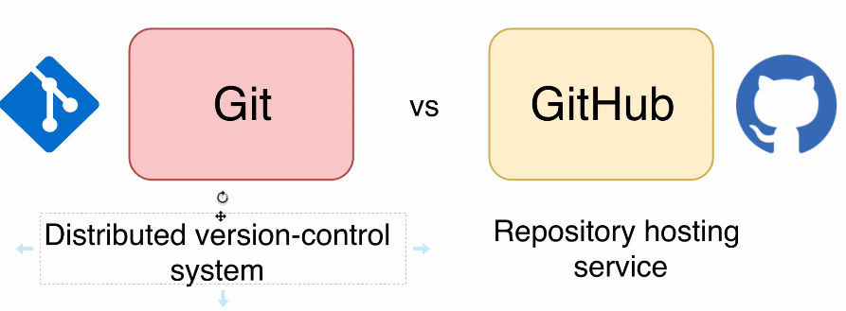

Let me quickly explain what is git and what is git hub and how they are actually related. Most popular definition of git is following:

* Git is distributed version control system.

But this definition is actually too complicated, especially for beginners. Let me explain you what is git in more simple words? Git allows you to track files in any folder called repository and git preserves the history of all changes that you make with files in this repository.

But how git does that how it stores all changes of all files in the folder?

Under the hood, git has its own, let's say, file structure And every file is stored in a separate document and every file has special **hash**.

And that's why we can say that **git is simply persistent hash map and it stores keys and values**, nothing else.

Key is a hash and value is content of every file.

Another important notice regarding git. You can use it locally on your computer. Even without internet and locally, you will have full access to entire history of all changes that you made in your repository.

Git doesn't depend on internet connection.

It stores all data locally on your computer and that is a great benefit of git.

But why is it called distributed version control system?

That's because you may collaborate with other people and work on the same project, and that's where GitHub comes in.

GitHub helps to manage your git repositories and usually git hub is used when different people work on the same project. But of course you may use Git hub even if you don't have any other collaborators, you may simply use Git Hub as a backup service for your repositories and even if you will delete your local repository, Remote repository at GitHub will still be available and you will be able to anytime download your remote repositories from GitHub again locally to your computer and continue working on them.

But of course distributed teams of people that want to work on the same projects will benefit from GitHub the most.

GitHub has many other features. For example, with GitHub you are able to create website with hosting with domain. It will be subdomain of github.io and you will also get free SSL encryption.

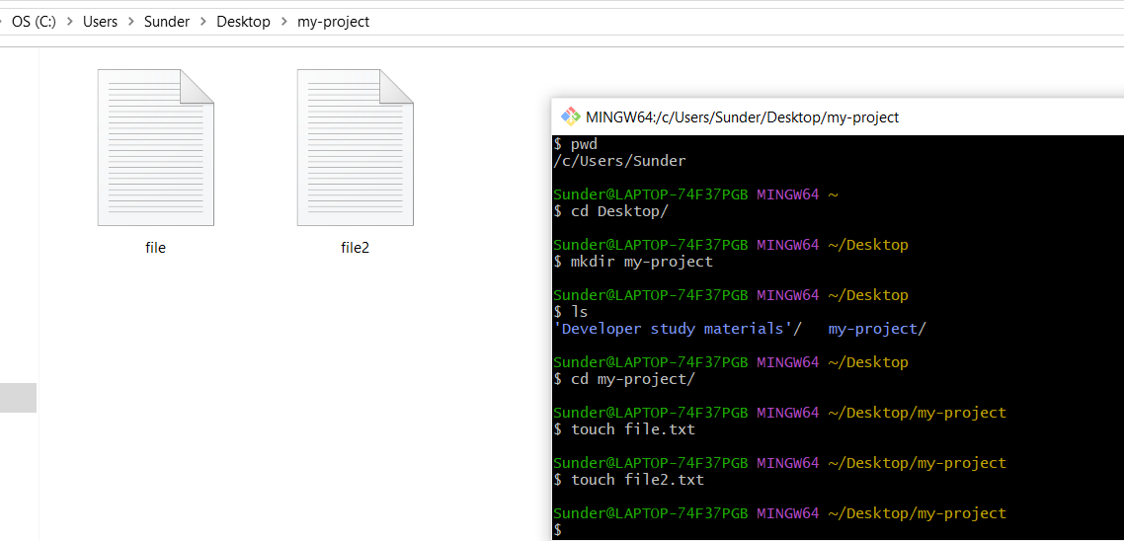

List files with their permissions: 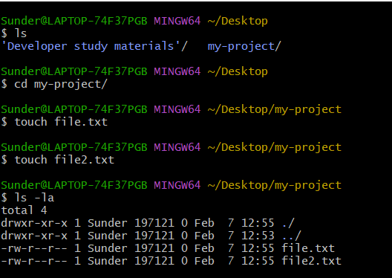

Here, if you want to lauch the folder in a new window, you can use any following commands:

start .

explorer .

Let us now initialize Git in this project:



You can now see the contents of the folder with a new folder called .git: 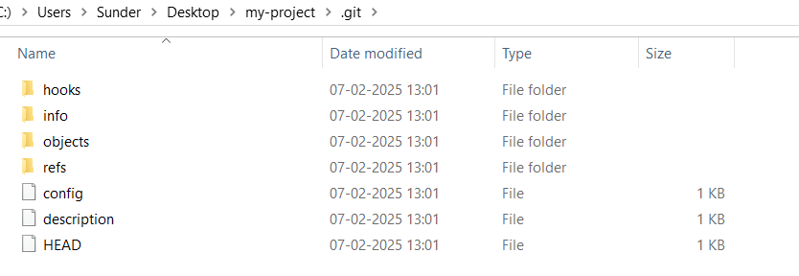

**SHELL COMMANDS:**

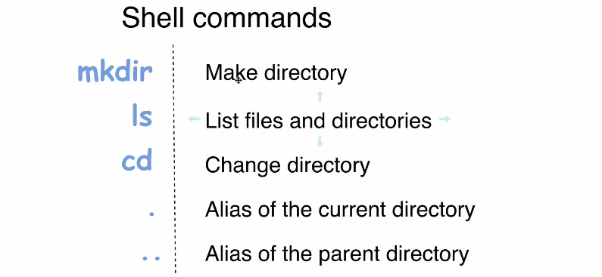

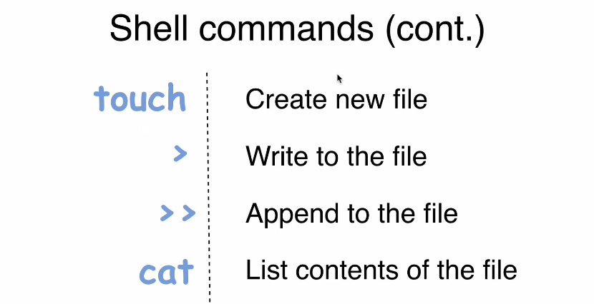

Here, I'll explain you how git works under the hood and how it performs its operations.And we will use some low level commands like git mkdir, **git hash**-**object** and git cat-file.I am sure that most of you never used those commands.Also, you'll understand which types of objects git stores in git repository.

There are actually four types: blobs, trees, commits and annotated texts. Okay, let's dive in. And I really hope that after this section you'll understand git much, much better and git will become easier for you.

In this section, we will be primarily focused on how git works instead of how to use git, but for explaining how git works under the hood, we need to initialize at least our first repository and for initializing of git repository you should use git init command.

Of course you should enter this command while you are already in new folder or existing folder whereyou want to create new repository.

This command will actually create a new empty git repository.And after creation of new git repository, you will be able to add new files to it.

But how it actually works.What allows you to add files to git repository under the hood?This command git init will create new hidden folder called **.git** 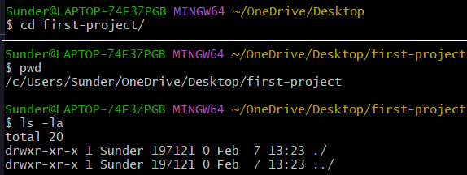

**Enter git init**

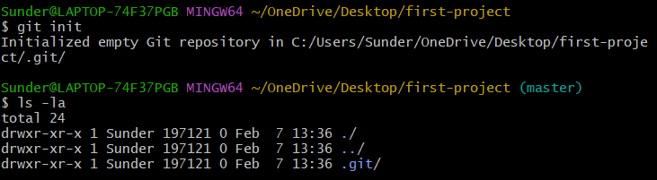

Now let's try to examine the contents of dot git folder.

Let's have a look at contents of those files: config, description and head.

And we can read those files directly from terminal.

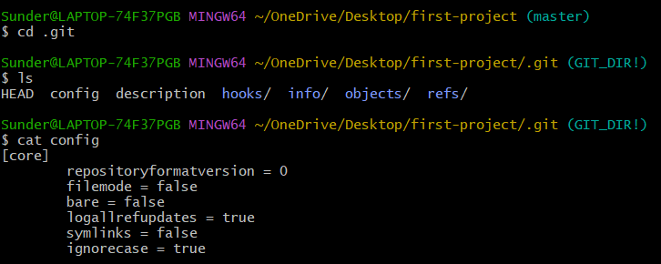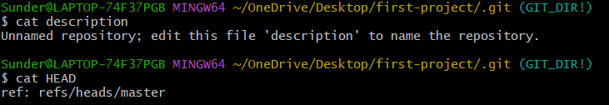

In its file system, Git stores objects and all objects are stored in this folder. And here at

the moment there are no objects because we have just initialized our new repository.There are several types of objects that git can store.And let's talk about types of objects.



In the previous lecture we have explored Hidden Git folder and it is highly recommended not to make any changes in this folder manually. Git has its own file system and it stores its own objects. And there are several types of objects that git can store.

Let's discuss git object types:

Now there are four object types in git and they are called blob, tree, commit and annotated tag.

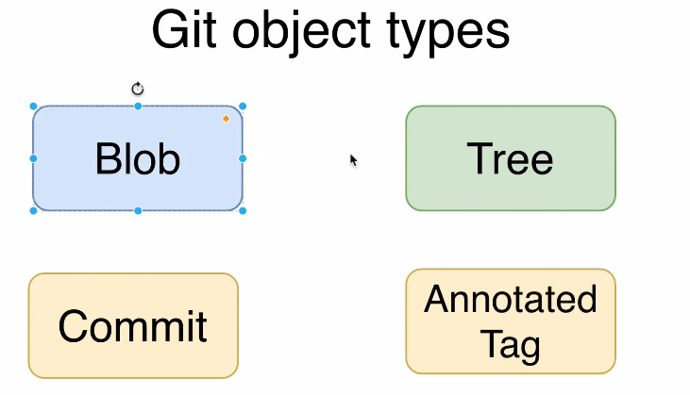And those four object types allow you to store all necessary data required for file tracking, for tracking of changes of files and so on.

* In **blob** object types, git stores files.Any files with any extensions, either video files or pictures or text files, Any files of any types are stored as blobs.
* Next is **Tree**. With help of tree object type, git actually stores information about directories and like in any other file system directory may be empty or contain files or contain other directories or have mix of files and directories.Tree in git may be a set of blobs. Again tree is representation of folder or directory in git.
* Next object type is **Commit**. And with help of commit object type, we are able to actually store different versions of our project.
* And last object type is **Annotated tag**. Annotated tag is actually persistent text pointer to a specific commit.

Recap:

That blob represents a single file in a git file system and tree represents directory or folder. And for management of blobs and trees, we will use so-called low level git commands like **git hash**-**object** and git cat-file.

With help of **git hash**-**object** command, we will be able to create new object in git structure with help of git cat-file command, we will be able to read git objects.

Okay let's create the very first blob in our new git project. 

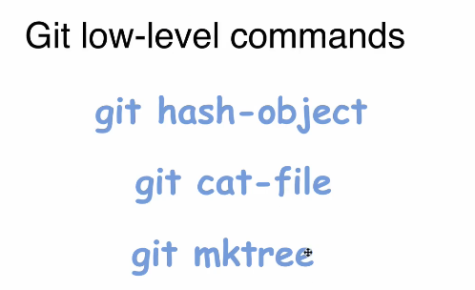

As of now, there is no new folders in the .git folder apart from the existing ones. Let us first print some statement on the console: 

Now, let us direct this one to one the first git commands called git hash-object . We need to do that using pipe symbol and then writing a git command and adding an option called stdin which means that git hash-object will take its input from standard input. Pipe means result of this operation will be set as standard input to this next command which is git hash-object

This is the command: echo "Hello, GIT" | git hash-object –stdin

We get a strange sequence of characters.

We can also use single quotes  or We can also omit the quotes and do as is:



Let us see if there are any changes in the **objects** folder in the folder .git: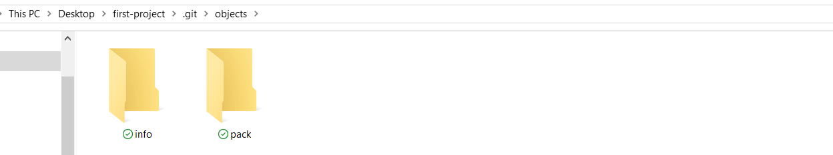

Still nothing. Let us add another option called -w



After this, it generates a new folder with first two characters matching the hash above:



Going inside: It contains a file with name consisting of the remaining characters after first two digits.



This means that GIT has added the object into the file structure. 

This hash is nothing but hash of this string Hello, GIT

We will no check what files were created using the command: 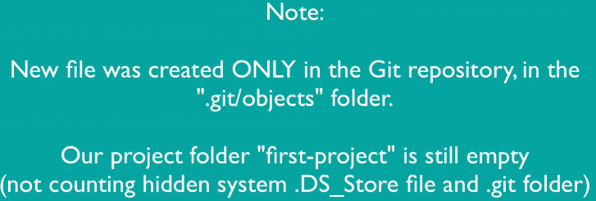



We saw previously that git creates names for folders and files Inside of those folders based on hash and hash is generated based on input. So here is input in our case.But before talking about hash, let me quickly explain you what is Json?

Json stands for JavaScript object notation. And if you have some relation to programming to any programming language, you should know this format pretty well. 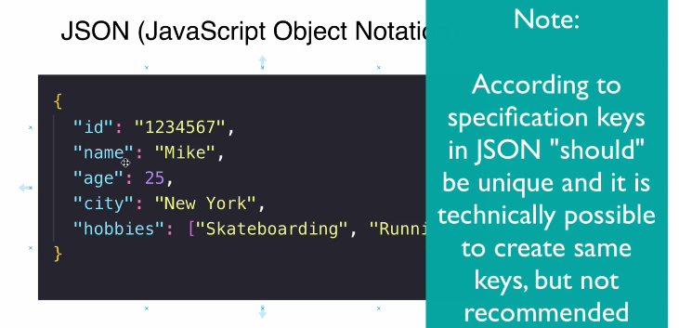 **This format is used for data exchange between different servers**.

For example, you can retrieve some data via API. Application programming interface from server to web browser, or you can send data from database in Json format to another server and so on.

It is just format for data exchange. Here you see sample structure of Json object. Here you see curly braces that represent starting point and ending point for this object. And object itself consists of set of key value pairs. Here, you see such keys as ID name, age, city and hobbies and values are different.Here you see string values.Here you see number and here you see array.

But values in this case doesn't matter.

What I wanted to show you here is that keys here are all distinct.

It's not possible to have same keys in same Json object.

Each key is unique across entire Json object. And values, of course, may match.

You may easily have same values in different key value pairs.

Hence, Json and structure of git database is pretty similar to Json. Git also stores, keys and values and key in git is equal to hash of each object.

And if I'll get back to the folder, you'll see that this folder, plus this file name is equal to hash of the file :

And of course, only single file with such name can be located in folder with name 36, same as with Json.We couldn't have two key value pairs with same key. But I have just told you that in Json it's possible to have same values in different key value pairs.

In git, it is not possible.That's because key in git is generated based on value. If I'll get back to terminal, you'll see that we have generated this hash based on this value.And if you have repeated those steps along with me, you got same hash here. Okay, now you know that git database is actually a set of key value pairs similar to Json objects.And now it's finally time to explain you what is hash and how it is generated. 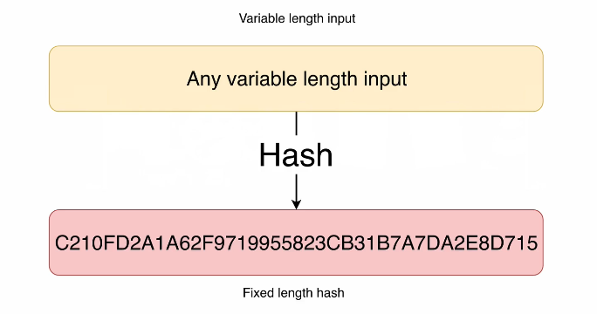



So far we have tried to use git hash object command with the -w option in order to create a git object from this string and write this git object to git objects database

It means that in git database, we store files based on their hash. First we create hash from the file contents and after that create corresponding file in objects folder.

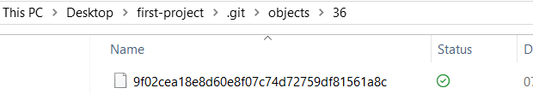

Okay, now it's finally time to explain you what is hash function and how it works.

**Hash function is a function that takes any variable length input and creates fixed length hash independentof the input.This hash length will be always fixed.**

For example, we can take just a short string like we did here:

**Hello, GIT**

and generate hash based on this string.

But also we can take other file much larger than this string we can take even for example **video file** which size is several gigabytes.

We can also take, for example, photo or something else**.Any file works here and hash function will always create hash of fixed length**. 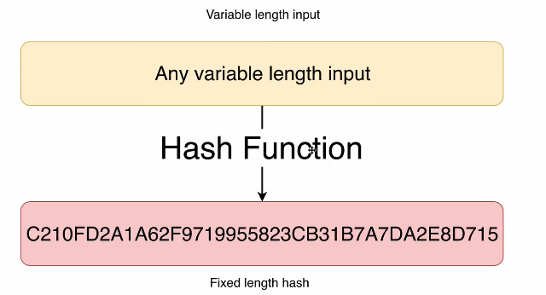

And there is a **very important characteristic** of every hash function.

**For a given hash you wont know the corresponding input, you will never be able to guess or decode this input based on hash.And such functions are called one way functions.**

**We are able to create hash based on input, but we are not able to find out which input was used to create specific hash.That's why very often passwords that you are entering on any website are stored in databases as hashes.And when you enter each time your password, when you are logging into any website or application,again hash is created from your password and only hashes are compared because hash functions will always generate same hash from the same input.**

**Hence,first characteristic is that hash function is one way function. Knowing hash, you won’t be able to get input value that was used for creation of this hash.**

**And second characteristic is that same input will produce always same hash.Please keep this in mind because it is important in terms of git.**



Now, you know that hash function creates a fixed length hash from variable length input. And it is a one way function and it always creates the same hash for the same input.

Let's now make a short overview of some hash functions. 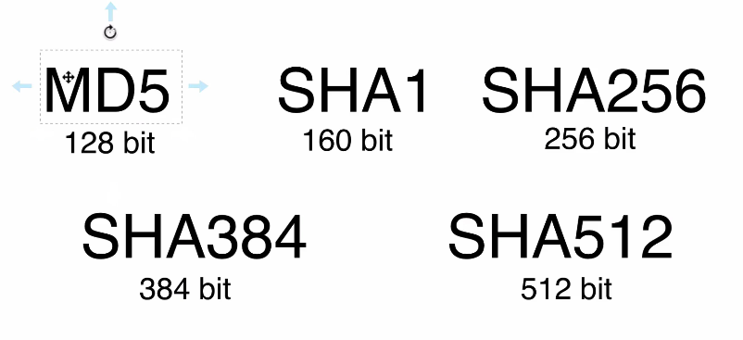 There are many of them, but here you see most popular:

* First, MD5.This function will create a hash that is 128 bits long.And as you see here, it is a small size among those hash functions.
* Next is Sha one and length of the hash that is created by Sha one function is 160 bits.
* There are also other modifications of Sha algorithm like Sha 256, Sha 384 and Sha 512 and length of the hash.

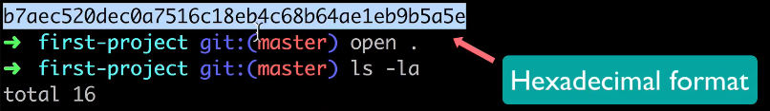 And if you look at this string, this one, it will be 160 bits long.But you may ask me the question, why am talking about bits 160 bits length hash?But here we see actually a string with letters and numbers.

**GIT uses SHA1 hashing function.**

That's because this format is hexadecimal format.It is used for more concise representation of the hash.



But there are two important questions.

First one, how many files git can store in the same repository?

And the second question is what is the chance of producing same hash for different files or rephrasing.

In other words, What is the probability of hash collision when two different files have same hash?

Answers to those questions are not straightforward and we need to talk about combinations first.

And let's first discuss how many combinations we can create. If we have only two places and two characters for each place, 0 or 1. We are talking here about base two or binary system. And here I have listed all possible combinations of zeros and ones on two places 000110 and one one. 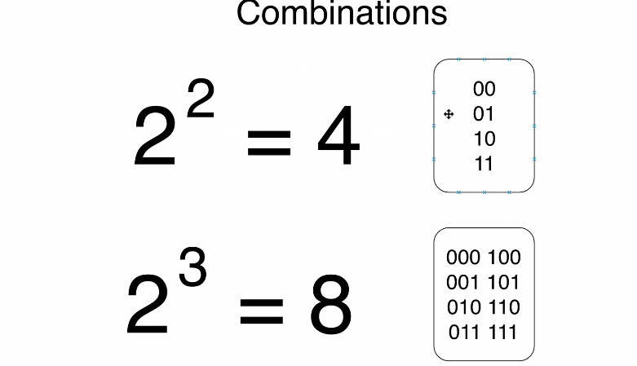 And total quantity of such combinations is two to power of two.That is equal to four.Same applies if we would like to find out.Combinations quantity for three places.And here I have listed all those combinations.First one is three zeros, then 001 and so on until three ones.Total quantity of such combinations is eight, and that is equal to two to power of three.Three is quantity of places where we can set either 0 or 1.There are only two possible characters, 0 or 1.That's why here you see two and three places.That's why power here is three.That is the basics.But what if we want to find out how many combinations we can create using Sha one hash?Let's have a look at this diagram.And here logic is the same as we have just discussed.

We already know that length of Sha one hash is exactly 160 bits. 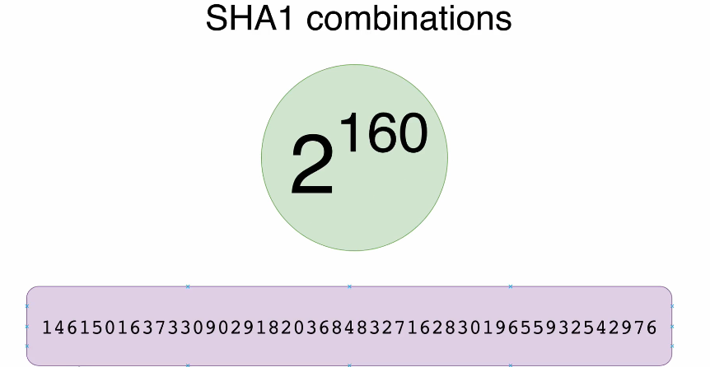 We have talked about that here.It is usually represented as **40 hexadecimal** **characters**.But now let's talk about binary format of the hash. On each of those 160 places could be either 0 or 1 two possible combinations.That's why if we want to find out how many combinations we can create in total, we should bring 2 power(160) power of 160. And here is the result in traditional decimal format. And this number is really, really large. And that is the answer to our first question.How many files git can store in the same repository? Answer is here to to power of 160.That is a quantity of possible sha one hash combinations.

This number is so huge that you shouldn't worry about ability of git to store all files in any repository. Even if you have billions of files in your repository, git will be technically able to store them in objects folder.Okay. We have answered this first question.How many files git can store in the same repository?

And answer is 2 power(160).

Now it's time to answer second question.What is the chance of producing same hash for different files?Or in other words, what is the probability of hash collision?



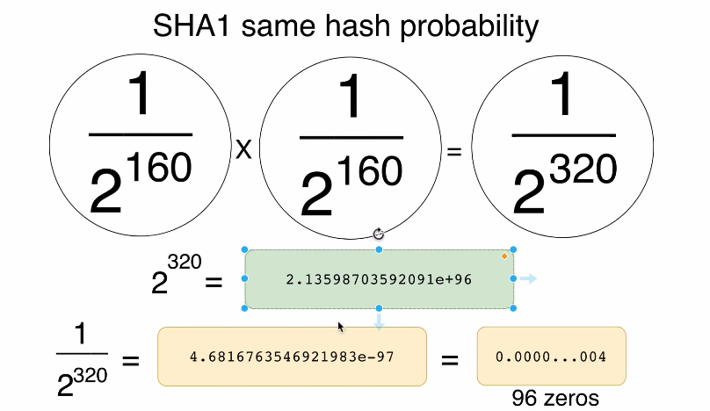



Now let's go on with low level commands and let's have a look at git-cat file command.This command has several options.

And let me briefly explain them to you.Here they are. 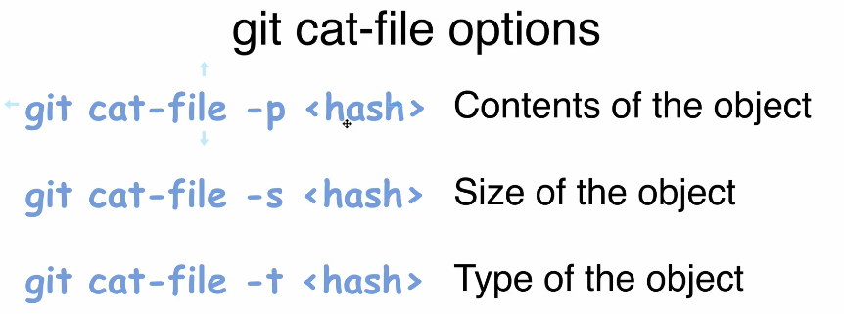If you'll use -p option then **contents of specific object with corresponding Sha1**

**hash will be printed to terminal**, but of course such object with specified hash must exist in git repository.

Next option -s will print **size of the object to terminal**.

And with last option -t, **you'll get type of the object**.

And before we have discussed that there are four object types in git blob, tree, commit and annotatedtag and when you enter git-cat file command with option, you'll get one of those values. Blob, tree, commit or annotated tag.

Okay, let's now try all of this in action and let's get back to terminal recap that there is single object in Git repository now and its hash is here. 

* -p



git cat-file -p 369f02cea18e8d60e8f07c74d72759df81561a8c

We got our contents of the file that we have stored in git repository.

* -s

git cat-file -s 369f02cea18e8d60e8f07c74d72759df81561a8c



We see size in bytes 11 bytes.

* -t

git cat-file -t 369f02cea18e8d60e8f07c74d72759df81561a8c



And here we see that type of this object with this Sha1 hash is blob and blobs are used to store rawfiles in git.

Let's now try to read information about the object that is absent in database

 I got fatal error, not a valid object name.And that is reasonable because there is no such file with such name in folder 36 and we can verify that there is only single file with name that ends with 8s .



Now let's try another option and let's create git object based on existing file using this command:  We don't need to use echo command anymore and we don't need to use stdin option.

Okay, let's try that.But before entering this command, we need to create a file file with some contents and let's create a new file on a desktop, **not in our git repository**.And then based on the contents of this file on a desktop, we will create new git object.

Okay, let's do that.



 

We can view the file:

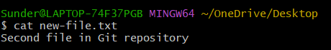

Now let's go back to our first project here and let's now try to create new git object based on this file.

After doing the above step ,here is Sha1 hash of this .We can verify that no new objects were created in git repository.Let's go to objects folder and here we still see only one 36 folder for objects.

Now let's use same command but with option -w :

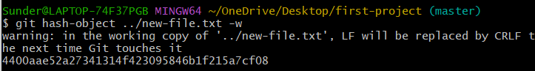

 And inside of this folder we'll see new file and name of this file matches remaining part of Sha1 hash: 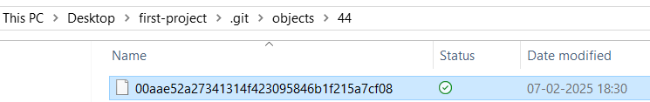 Let us try to read contents of this new object. 

Now, with another option -t



And finally with the option -s



Now let us go back to the path where new-file.txt is located in the terminal and delete the file:



Even after deleting the ile physically, we can still see the object in the git: 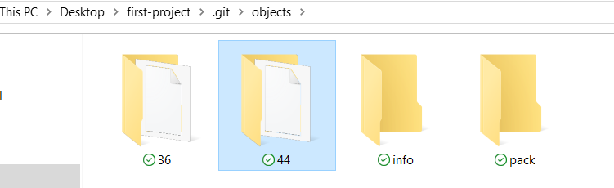

With this, it is understood that Git repository stores files independently in its own “File-System” in the “objects” repository.



We came to conclusion that git blobs don't have file names.What does it mean?Actually, each blob that is stored in the objects folder has a name, but this file name is based ona Sha1 hash of every object like 44 or 36 etc., but it is not the file name, that is actually blob name.

For example, here you see folder 36 and inside of it you see this file or in a previous lecture we have created one more file and it is located here in this folder.But this git object.Git blob was created based on the contents of the file and name of the file was not stored in this object.

 There are actually three main areas where files and folders may live in git and they are working-directory, staging area(index) and git repository.

Again, you are already familiar with structure of git repository and you know how files are stored there and every object in git repository has a file name that is based on Sha1 hash of that object.



Recap: Git blobs don't store name of the file that was used as source for creation of git blob. Also, we have discussed that object type and object length are stored inside of the blob and now it's a good time to explain you structure of every git object.

Git object consists of four fields. 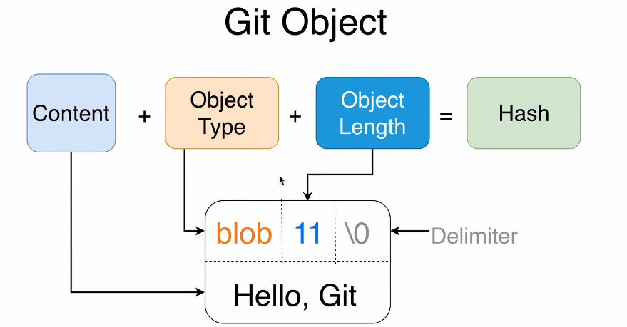1.Object Type,

2. Object Length,

3.Delimiter and

4.Content.

And here you see an example of the blob.Here object type is blob. Object length is 11.

Here you see delimiter. It is actually null character and it is written as backslash zero. And after that comes content. And in our database, in our first project, we have such object type blob.Object length is 11 and content “Hello, GIT” .

And it doesn't matter how this object is created, there are always only four fields inside of actual git object in git database. How can we prove that?

There are two ways.

First is to read contents of git object directly and

Second, by creating Sha1 hash of those contents and comparing resulting hash with the hash that was generated by git hash object command. In our case this hash: 

Now let us list the files in the **objects** folder: 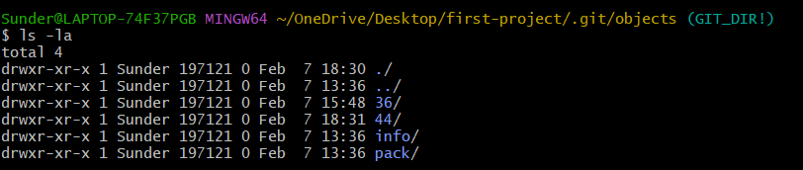

Let us try to read it: 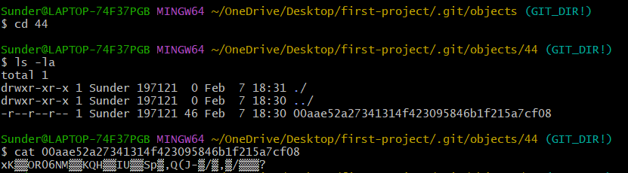

Since the file is compressed, we cant read it using cat command. Hence, that is the default structure of the blob object.



Tree is one of four object types in git. And before we have talked about blobs and using blob, you are able to store any file inside of the git repository.

**But please note that blobs don't store file names of the source files** and each blob consists of contents of the file type of the file size and delimiter(Backslash zero) and name of each blob is based on a Sha1 hash of each file.

And tree object type in git is representation of directories and each tree may contain blobs and other trees.But what is the structure of tree object type?

Its structure is the same as structure of the blob, but instead of the blob here will be tree. Here will be size of the tree again, delimiter and contents.But what about contents of the tree? What will be stored here?



Let me show you this example. 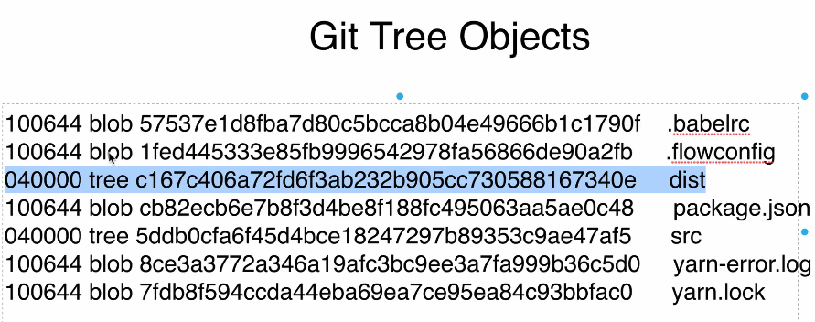

In this example you see contents of one of the trees of the Real World project.And here you actually see list of links to other blobs or trees.And every line contains four fields.Here you see permissions.Then comes type of the object tree or blob.Then comes Sha1 hash of this.In this example three.And then comes name.And that's where file names or names of directories are stored.

For example, here on the first line you see link to the blob. 

Here you see permissions for this blob.Then Sha1 hash of this blob and name file name for this blob.That's why we don't need to store file names inside of the blobs.File names are stored inside of the tree objects.Okay. In this example, you see that this sample tree object contains other trees here or here.But in some cases when tree doesn't have child trees, it will contain only blobs.Okay.Now you see how simple is structure of the tree git object?Now let's make a break.And after a small pause, let's talk about permissions that appear here at the beginning of each line.



There are six possible permissions, but most often you'll see first one and second one: 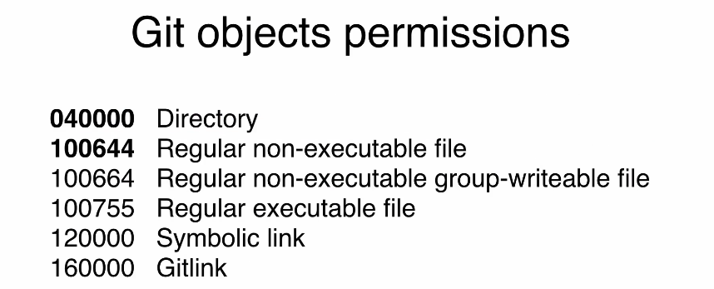

First one represents directory.

Second one represents regular non-executable file.

And for example, executable file will have such permissions as 100755. But you may ask me why do we need those git objects permissions?

Answer is pretty simple. As you know, git repository is independent from your file system. It is own file system of the git and based on git repository you are able to create files and folders on your computer.



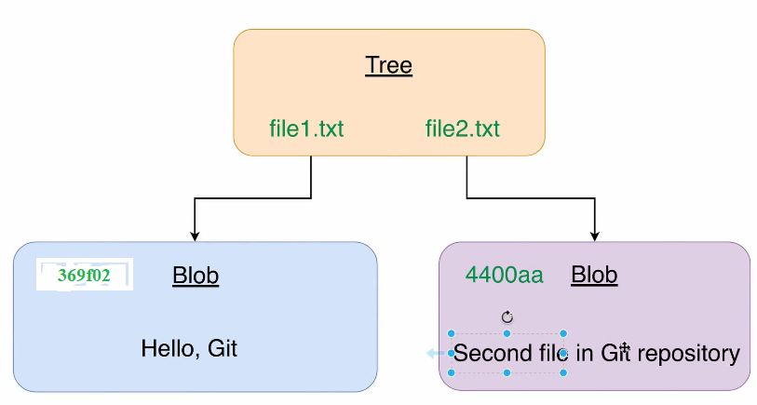

Currently in our git repository there are two blobs with contents: ”Hello,GIT” and “Second file in Git repository”. Also those blobs have their corresponding Sha1 hashes and starting from this diagram I will not use completeSha1 hash for git objects.Instead, I'll usually use 5 or 6 first characters that clearly indicate specific git object.

Now it's time to create new git object of tree type.And inside of this tree, we will add two pointers to existing blobs to 369f02 & 4400aa . And as you can see that file names are specified inside of the tree object.

|  |
| --- |
| 100644 blob 369f02cea18e8d60e8f07c74d72759df81561a8c file1.txt |
| 100644 blob 4400aae52a27341314f423095846b1f215a7cf08 file2.txt |

And in our project, let's name those files as file1.txt and file2.txt.

Those objects will be blob and file. Permissions will be for both blobs equal to 100644.

They are regular non-executable files

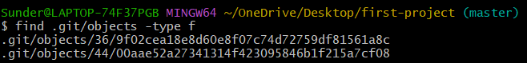

And you see two files inside of the folders 44 and 36.Here is our first file, first blob, and here is our second blob.Okay.So far we have two files in two folders 44 and B7.

Now let's create one more git object and it will be tree object. For that we will use mktree command. And first, let's take a look at the **help** for this command.

git mktree –help

It launches a browser with these: 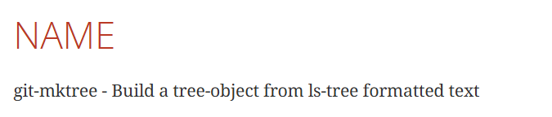

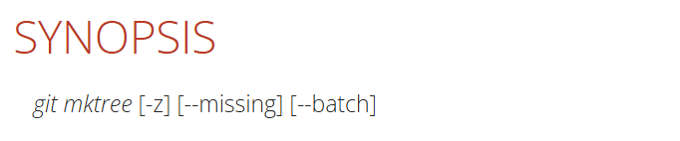

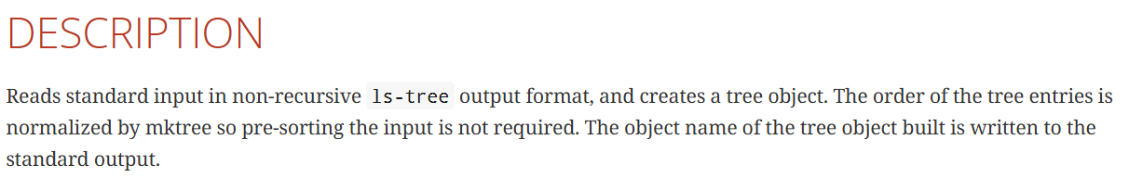

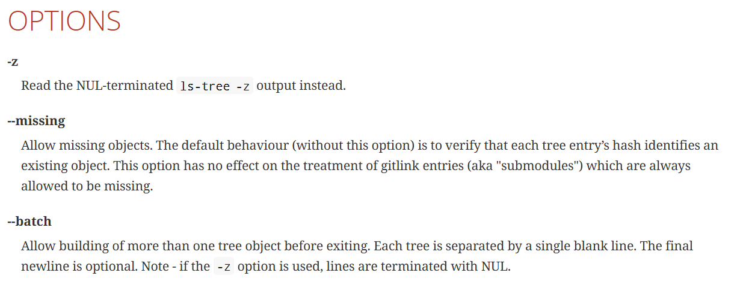

For now, we need somehow create tree object using Mk3 command and the way how we can do that is following.Let me close this help and we will do following.We will create new file and put contents like those mentioned in the table above inside of this file.

Let's do that and let's create new file again on the desktop in order to avoid confusion with our Git repository and our first project folder.

And after that use nano editor in order to edit it. But I can also use nano editor straightforward without touch command like that nano:

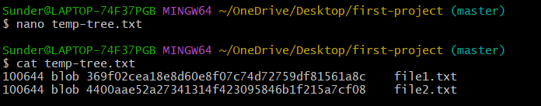

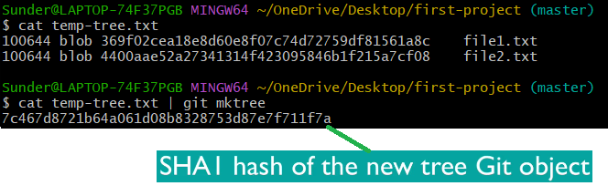

Now, we can see the new tree object: 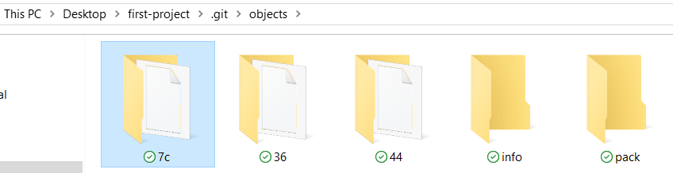



Just use the SHA1 of the tree previously made to examine the contents.

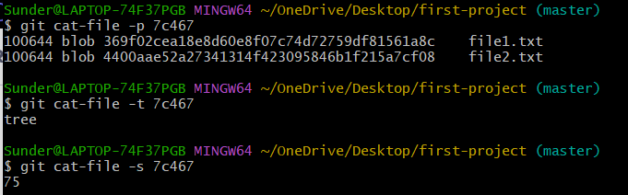

Nothing fancy or indicative that this tree connects to these two blobs. If the content of the tree has these two blobs then it implies that it has two blobs pointing to it.



But now it's time to talk about staging area that sits between working directory and git repository.

Staging area is usually called index and staging area is actually responsible for preparing files to be inserted into git repository and in opposite way it prepares file taken from git repository to be put into working directory. Please note that putting files into staging area or index is mandatory step in all git operations either when you want to place files from working directory into git repository or when you want to read files from git repository and checkout them into your working directory, staging area or index always sits in between. Let's examine files in our first project and their distribution among those three areas: Working directory, staging area or index and git repository.

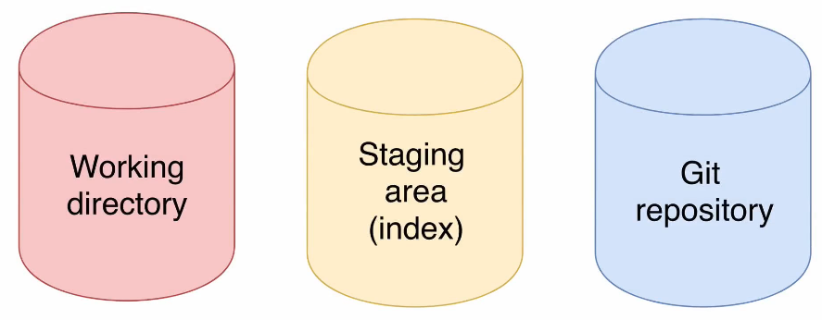



Let's now have a look at our first project in terms of those three areas where files may live in. There is a tree and inside of this tree there are two links to two blobs and we have added file names for those blobs.

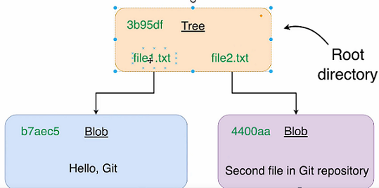

Note:Don’t mind the SHA1 numbers, its from the Instructor’s example

**And we have created this tree object in one of the previous lectures that are three objects that are now located in Git repository here.But please note that there is no other tree that points to this tree and that means that this tree object represents root directory.This is very, very important**.

If you would like to put those two blobs into another tree that will represent folder with name, you need to create one more tree between those blobs and this root tree.We will not create one more tree now.

But you should understand that this tree in our first project represents root directory because there is no other tree that points to this tree. That's our tree objects that are located now here in Git repository. 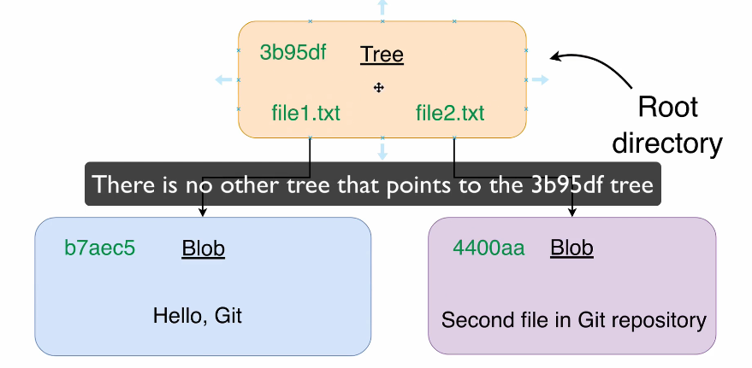

That's our tree objects that are located now here in Git repository.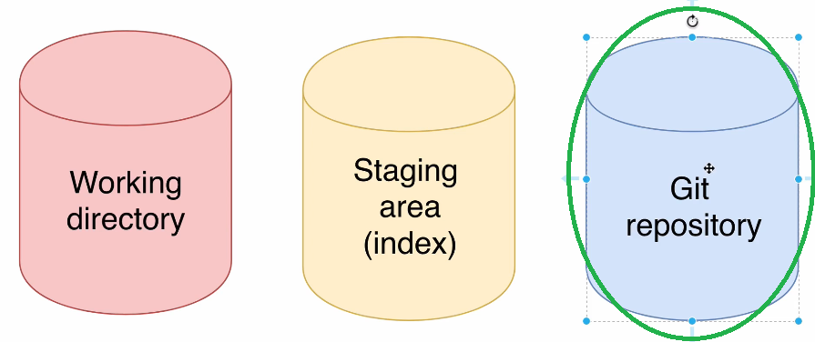

Now let's examine our working directory and for that we can simply open up explorer: 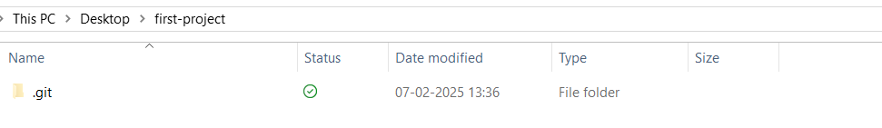And here you see folder first project.And at the moment there is only one hidden folder .git.

Okay, that's our working directory.

Now let's examine staging area.And for that there is a special command called **git ls-files -s**: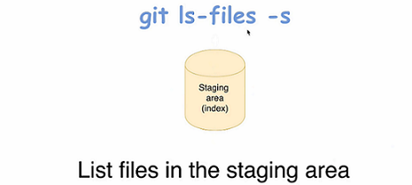

And here you see that Now index is empty: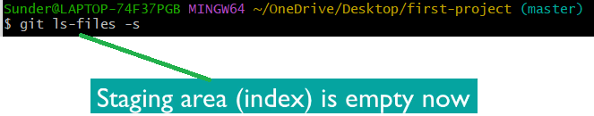

There are no files in git staging area.

It means that there are files only in git repository.There are no files in staging area or index and there are no files in working directory.

And that means that we can represent our current situation in first project in following way:

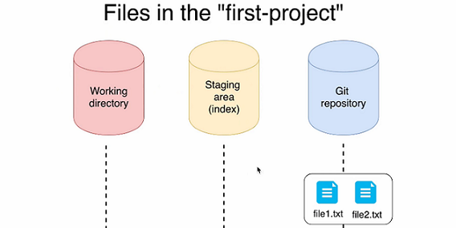

Working directory is empty, staging area or index is empty and in git repository there are two files. **Actually there are two blobs and one tree that points to those two blobs and those file names are located inside of the tree**.That is our current file's distribution among those three areas.

Now it's time to take those files from Git repository and put them into staging area or index.



In order to retrieve files from Git repository and put them into staging area, we should use:

**git read-tree <hash>** command:

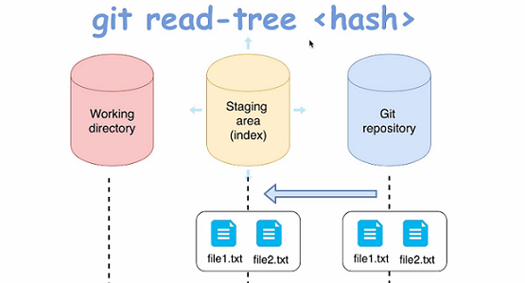

This command requires Sha1 hash as argument which is nothing but SHA1 hash of the tree object.

And when you enter this command git will try to find git object with such hash.

And after that, if object is found, it will take entire tree under this object and put it into staging area.

After this operation, in our first project, two files should appear here in the staging area.Again, there will be no tree because this tree represents root directory.

Okay, let's try to do that and let's do that in the terminal here. Let's first list files in our Objects folder. 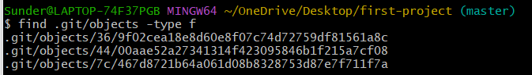But any other person that will look at all those files will not be able to guess where is three or whereis a blob. And at the moment there is no other way to get information about that except git cat-file file command because at the moment we have files only in git repository: Since we already know the tree’s SHA1 by memory, for now let us not make a huge ruckus and just add files to the staging area: 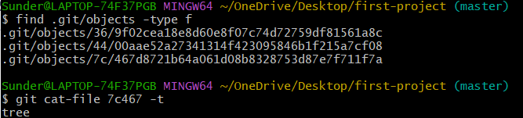

Please use the Terminal of VSCode since Gitbash isn’t good at CRLF ending for Windows and was throwing errors:

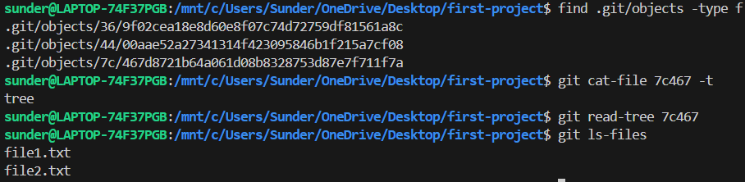

Hence, we now have two files in the staging area: 

The 0 here signifies that those files in staging area are same as the files in the GIT repository and were not altered.

Let us now put these files into the Working Directory.

**git checkout-index -a**



Here are the two physically available files: 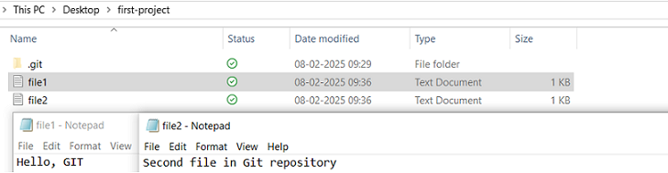

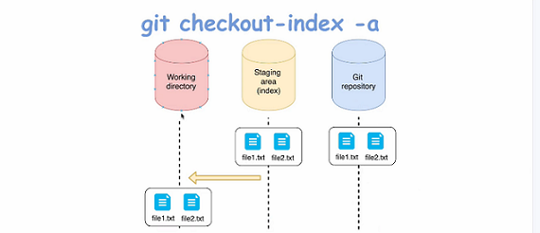

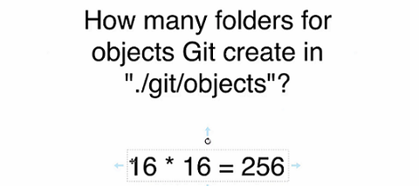



Commit is another git object type that we have not yet discussed. In a command line here, you have seen that there are no commits yet in our project: 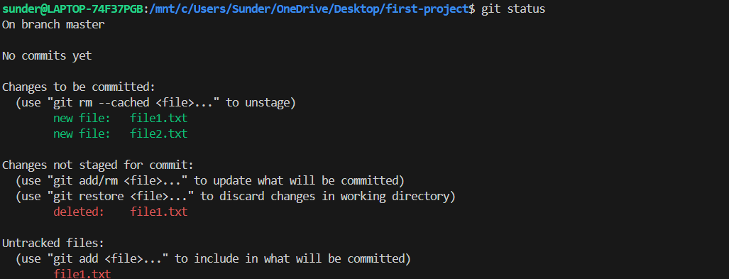

What is commit?

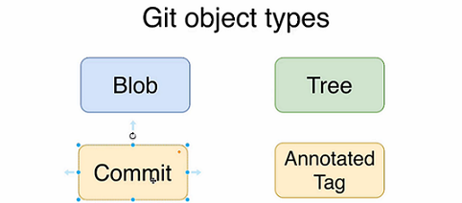

First of all, commit has the same structure as blob entry.

It contains object type, object lengths and contents of the object.

But what are contents of every git commit?Each git commit has following info inside:

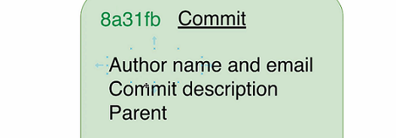

Author name and email, commit description and parent.(Parent is optional).

Also of course, **each commit has its own SHA1 hash. That's because commit is regular git object and every git object must have SHA1 hash**.

But what is the purpose of Commit? Why do we need this special git object type? Commits allow us to store to store different versions of our projects or let's say, snapshots in git database.

Using this, we will pretty easily move fast to any version of your project by checking-out the specific commit.

But how come it actually stores current version of the project or current snapshot?

There is one more field that is absent here.

And this field is pointer to specific tree object in Git database.Let's have a look at this diagram.

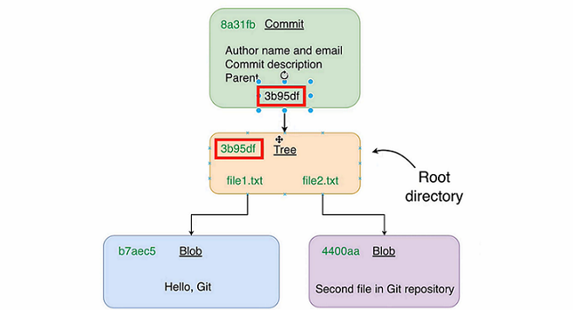

And here you see our three objects in Git database that we have already created and commit is simply a wrapper around three object and **commit contains pointer to specific tree**.

And here you see SHA1 hash of this tree object. It matches this SHA1 hash here.

Commit is simply a wrapper around three objects in the database. 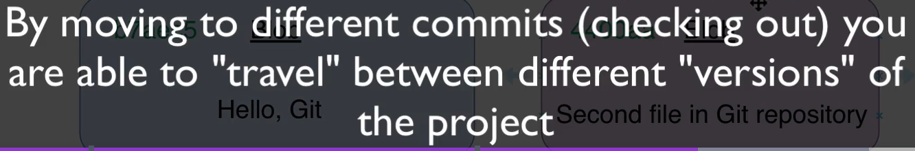 **We can move around the commits using a mechanism called checking-out.**



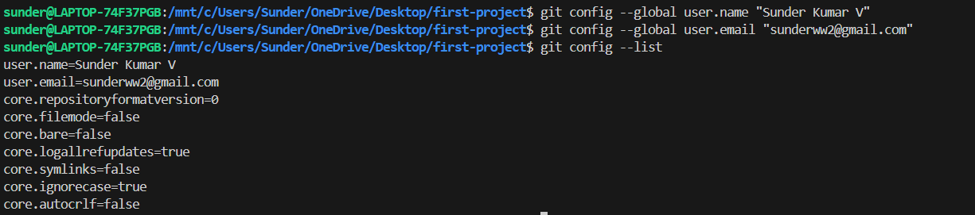

git config --global user.name "Sunder Kumar V"

git config --global user.email [sunderww2@gmail.com](mailto:sunderww2@gmail.com)

git config --list



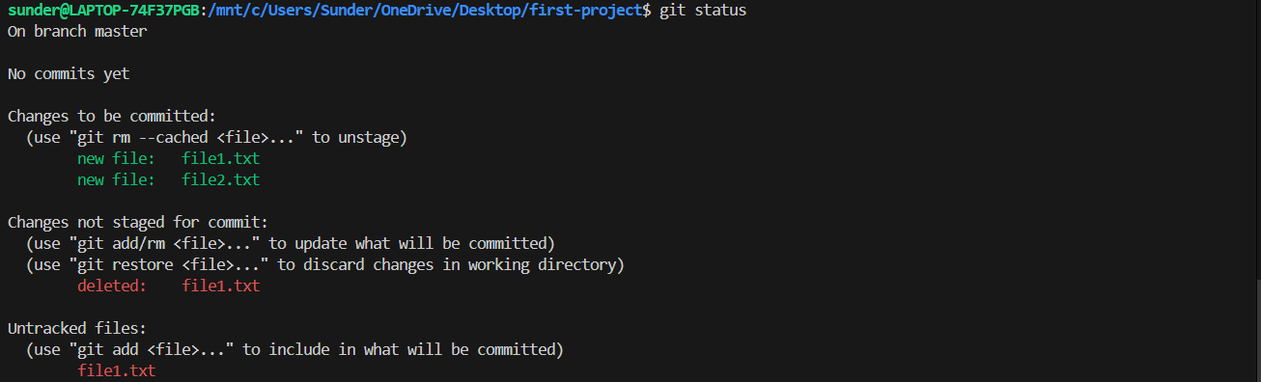

To first commit, we need to add the files to the staging area(index):

git add .

or to add individual files , you can use:

git add <filename>

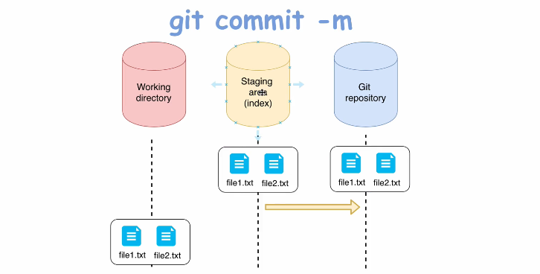

git commit -m "Our very first commit"

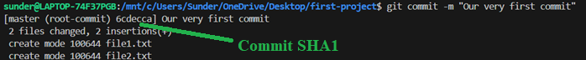

Explanatory: This commit is our first commit in our project, and that's why it is called root Commit.It doesn't have any parent commits.Later on we will create other commits that will have parent commits.Here you see SHA1 hash actually part of it of this new commit.You know that every commit is just a git object and every git object must have SHA1 hash.Next you see description of this commit our very first commit in the project.And here you see that two files were changed and git has created two files file1.txt and file2.txt. With those permissions, but you may ask me where git has created those two files.?



You can check the commit-id by looking up the git log:

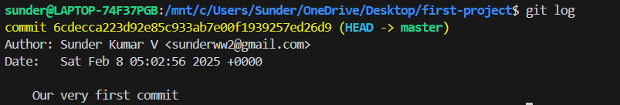

Let us now examine its contents: 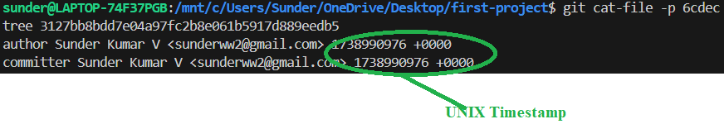 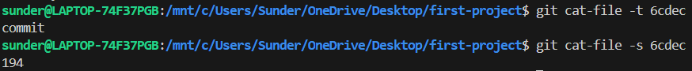

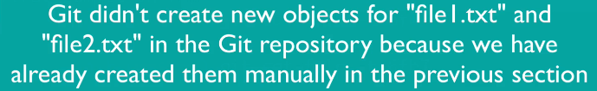

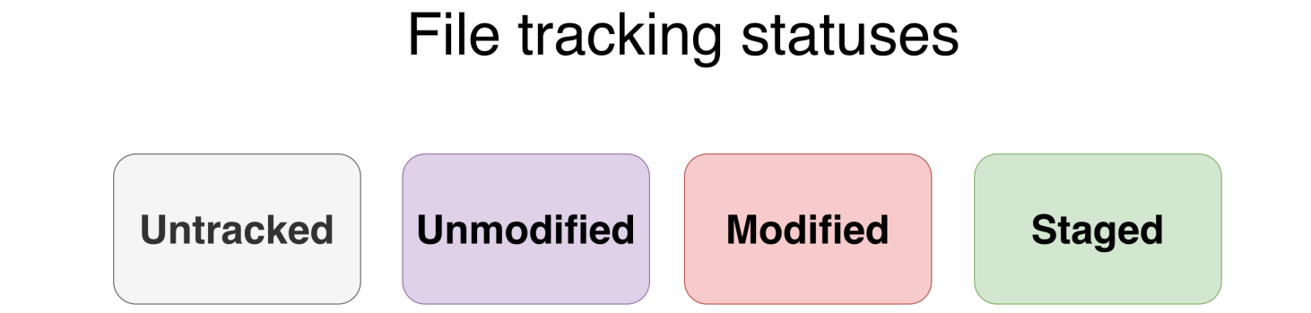

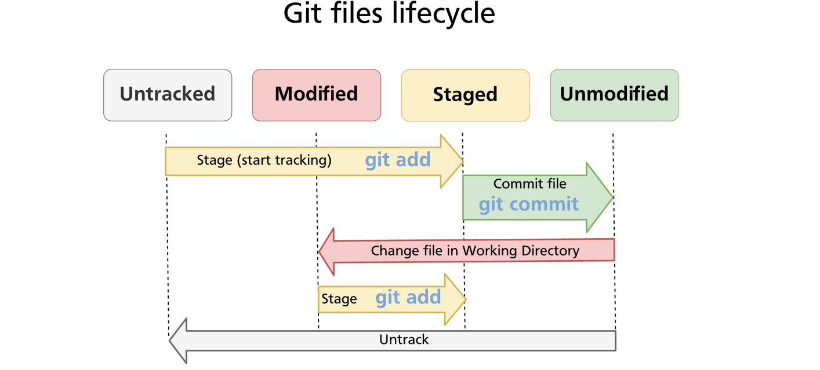

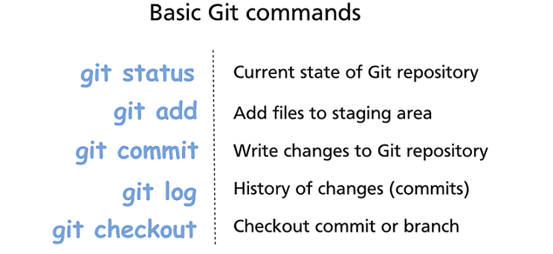



Let us add a file to the staging area: 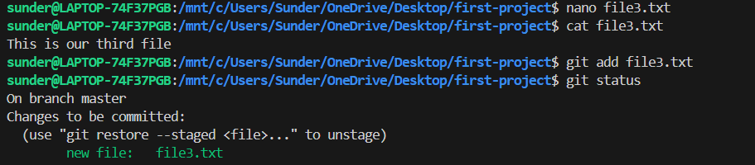

git rm --cached <filename> 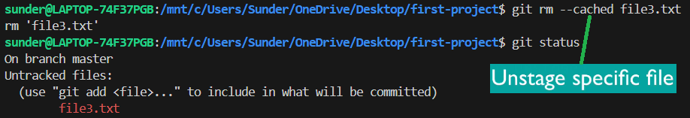

We can also unstage a file using this command:

git restore --staged <filename>

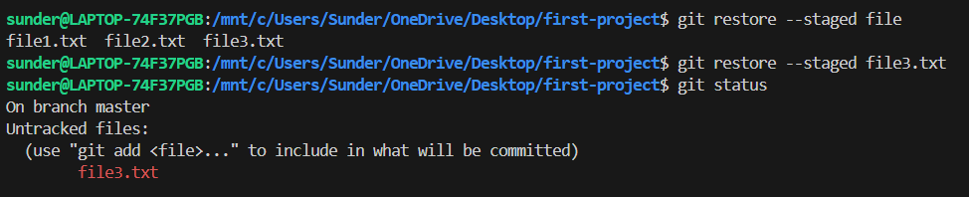



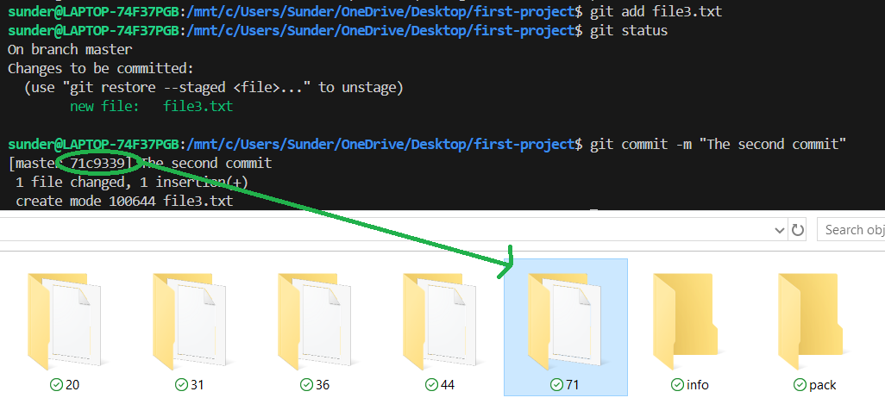



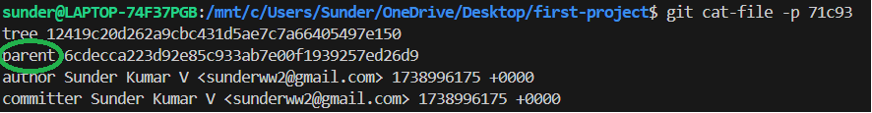

This one has a parent commit but if we check the parent 6cdec, it has no parent because it was a root commit and wont have a parent. Since there it has no parent, this will become a parent for all the subsequent commits.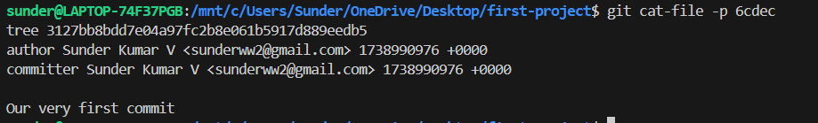

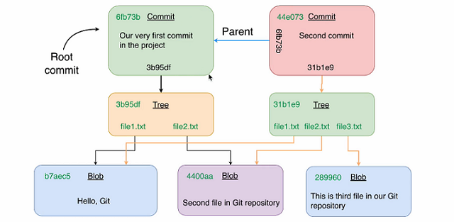

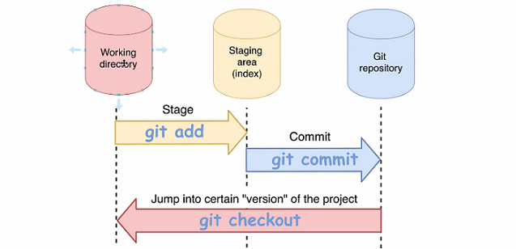



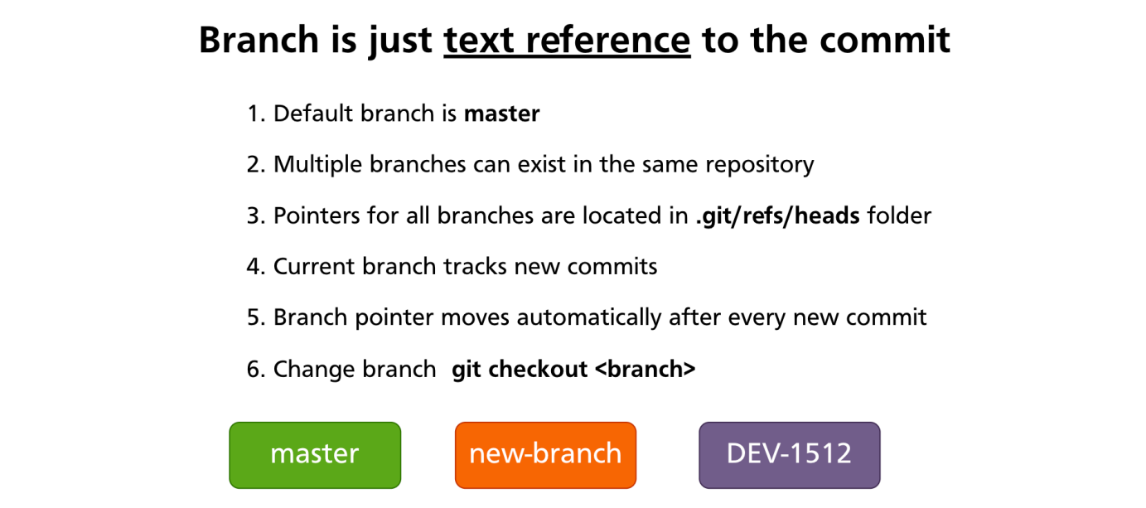

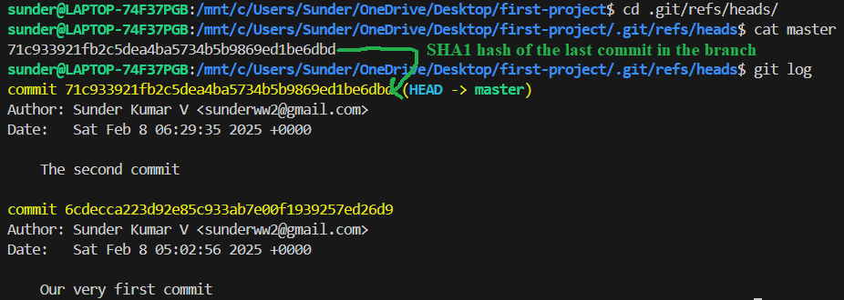

**Hence, the master branch is not really a branch, it is basically a ‘COMMIT’ which always changes with new commits and it will always be the last/previous commit’s SHA1 id. Hence, proved that it always like a pointer automatically after every commit**.

Can you observe this?

**(HEAD -> master)**

It says HEAD is a pointer to the master. What does it mean?

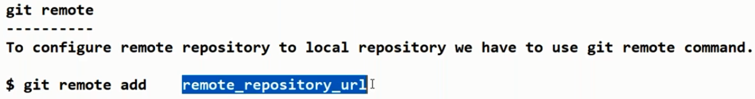

We can use any alias name like your wish:

-v means verbose

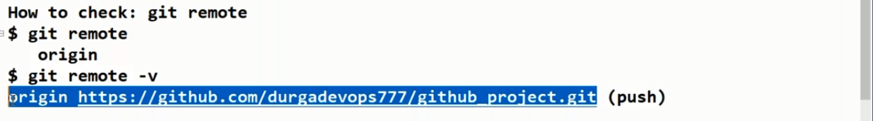

git remote add [<options>] <name> <url>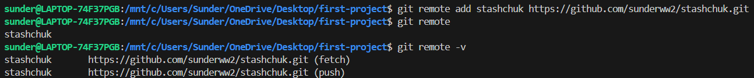

Use always the PAT as the password and never the login’s password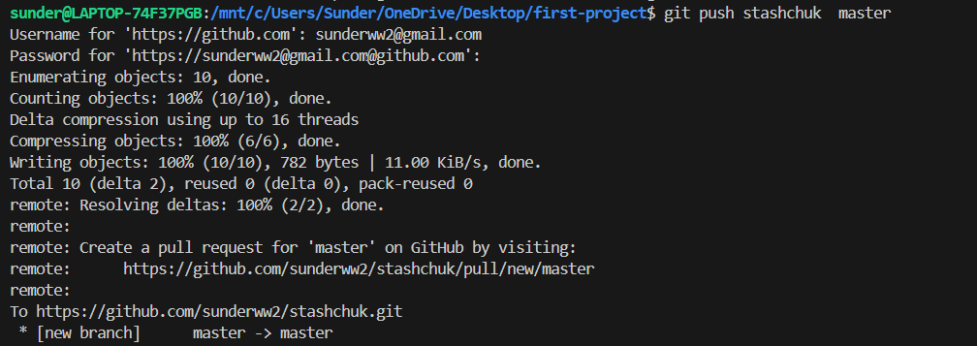

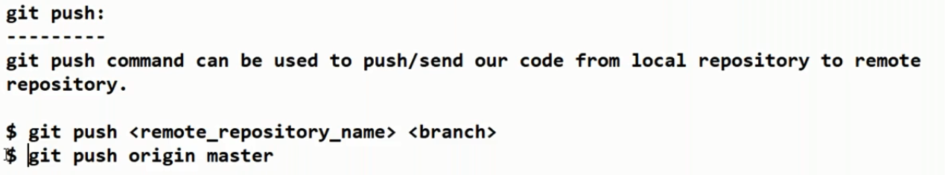

When we write **git remote**, this local repo is not associated with any remote repo, to add one, do the second command as shown below: You can use any name ,its not mandatory to use **origin** only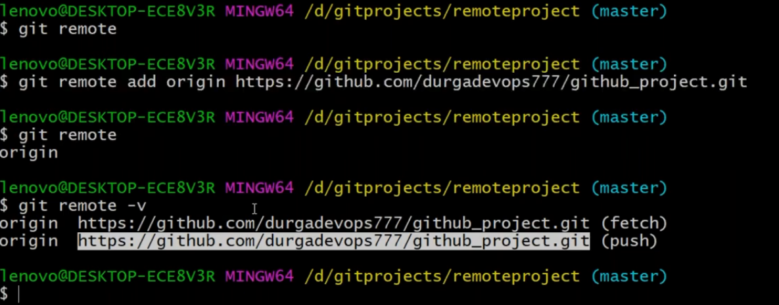

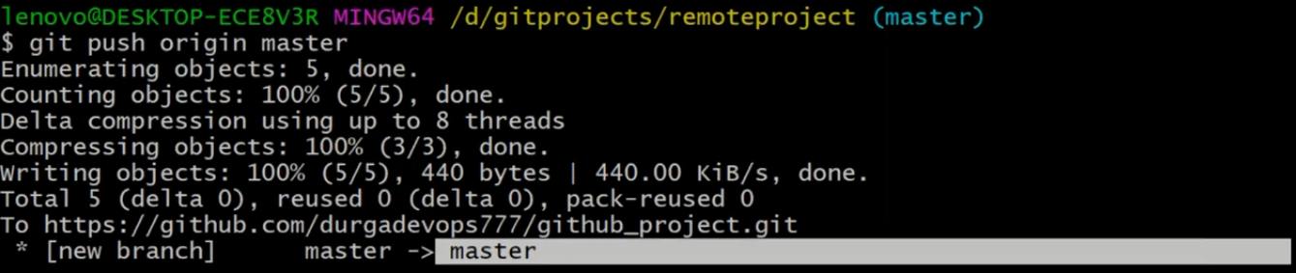

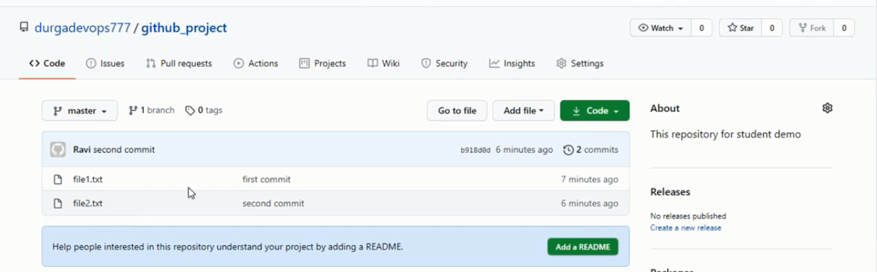

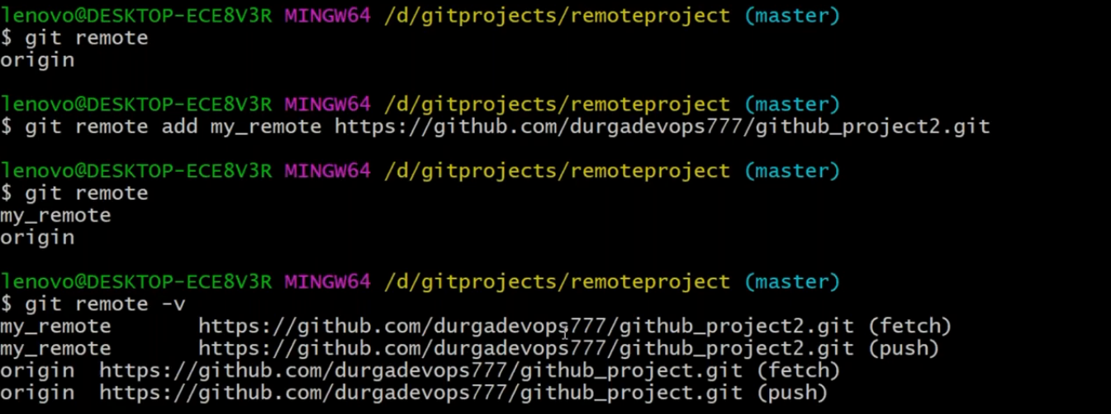

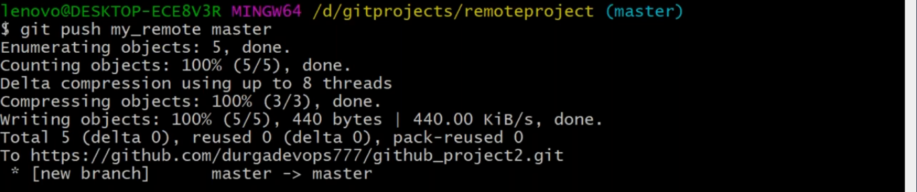

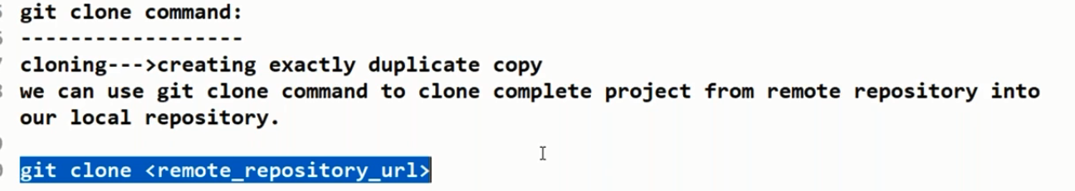



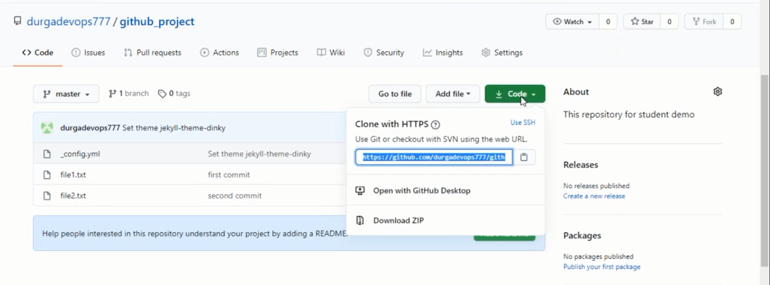

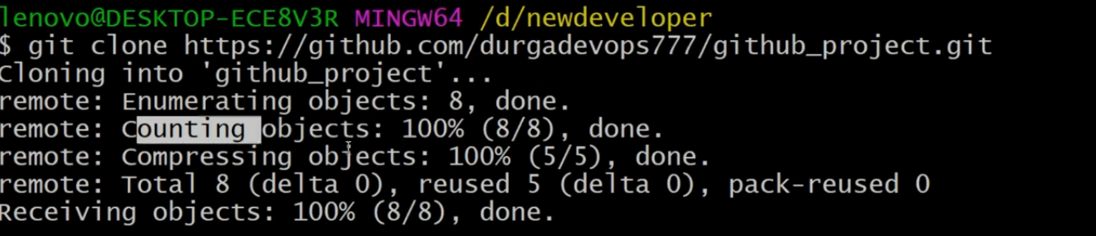



Proof that git fetch doesn’t download the changes: 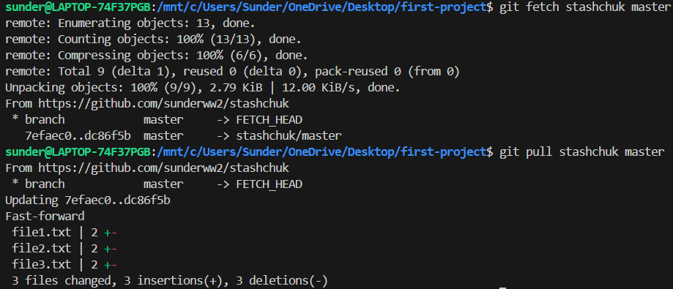

To download the above changes, we have to use: **git pull**

**To pull from a specific branch of the remote: git pull <remote> <branch>**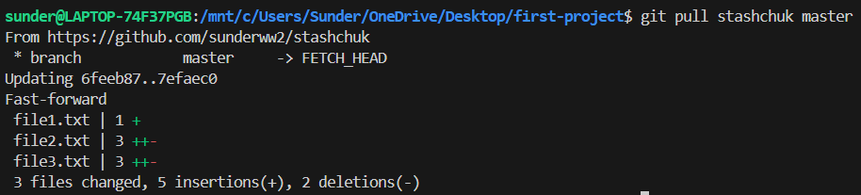





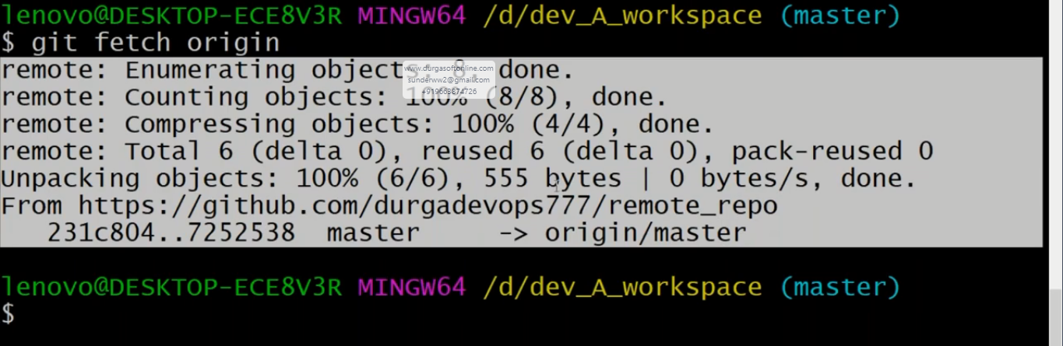

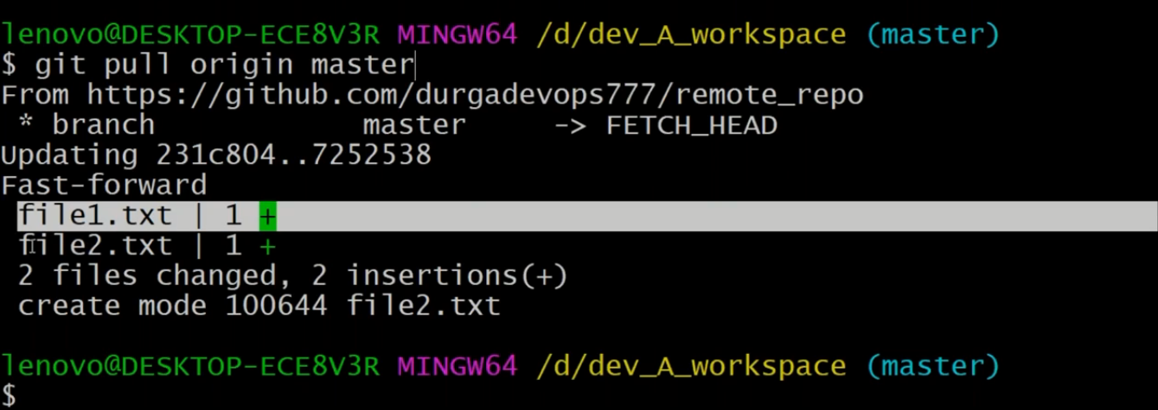



Before we know what is HEAD, let us ask How does GIT know which branch is current?

Every branch is just a pointer to the specific commit.And this pointer will NOT change if you do not make any new commits inside the specific branch.

If you look carefully in this diagram below, master points to the latest commit: 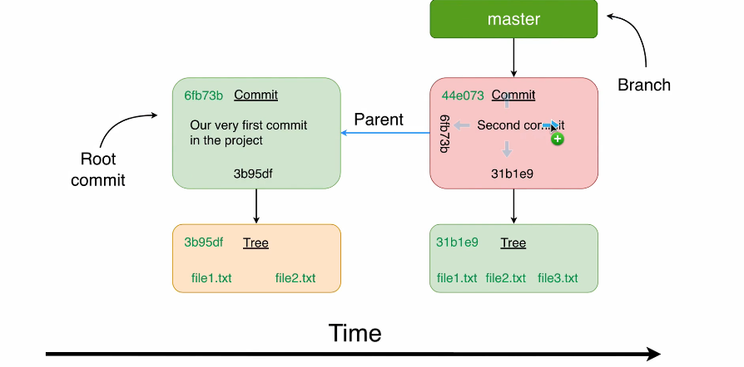

Same was reflected in the console too: 

Also there can be be various other branches existing. So now back to the question, How does it know the current branch is master or some other branch?

HEAD. This is where HEAD comes to the rescue. It is a pointer tht specific branch(commit).

There can be multiple branches(commits) but there will always be only one HEAD. It’s a pointer to the current snapshot(version) of our project.

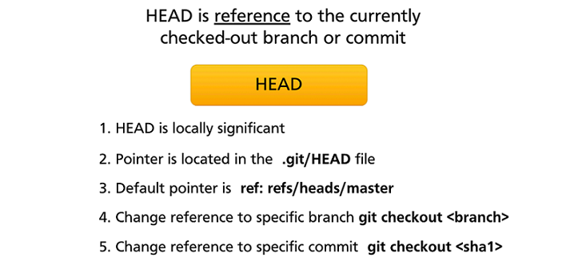

* **HEAD is locally significant**: It means that if you work in distributed project and you host your project on GitHub, for example,you can move ahead as you want.It will be moved only locally in your project, on your computer. It will not affect remote repository or remote developers in any way.
* Git stores this pointer in a file called head in the root of the git folder. 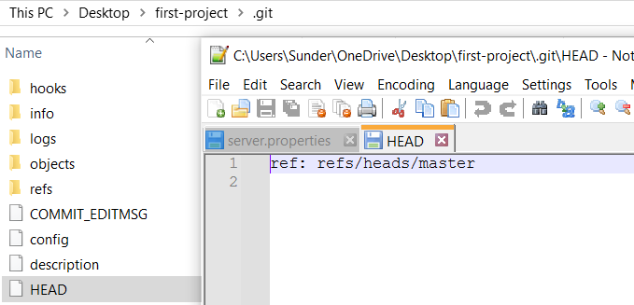
* Next default pointer is ref:refs/slash heads/master. And this path is already familiar to you.Refs has master.This file stores pointer to last commit inside of master branch. 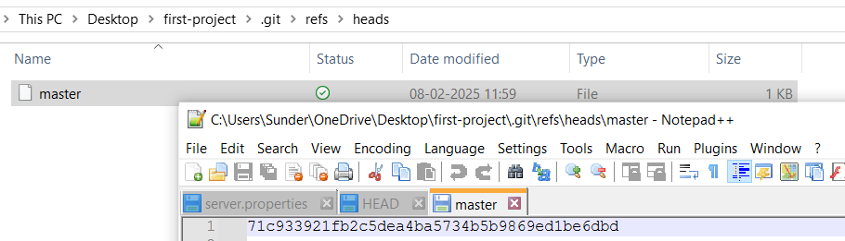
* Next, you can easily change position of the head and you can point it either to a specific branch or specific commit.

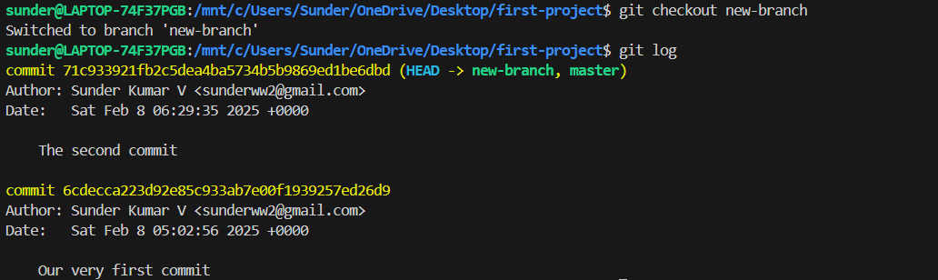

You can see the HEAD is pointing to new-branch now and not master.

* Alternatively, you can also checkout a specific commit id instead of a branch by using the last command.
* 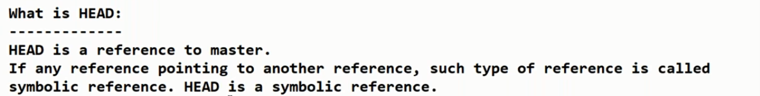
* 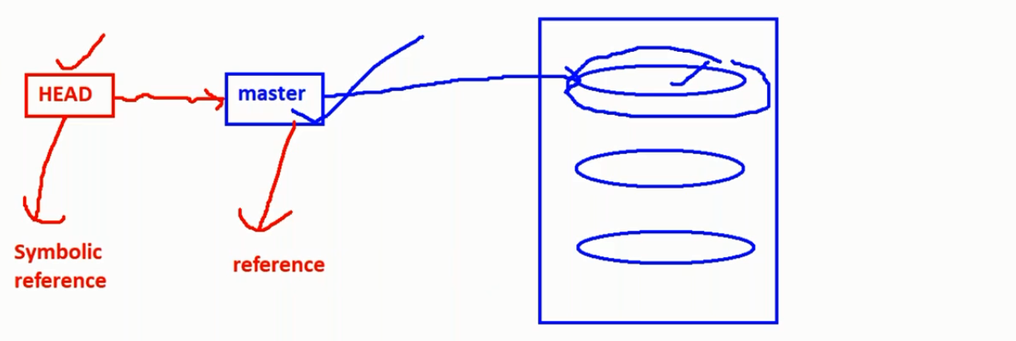
* 
* If a head is pointing to something else other than the master , then its called detached head.
* 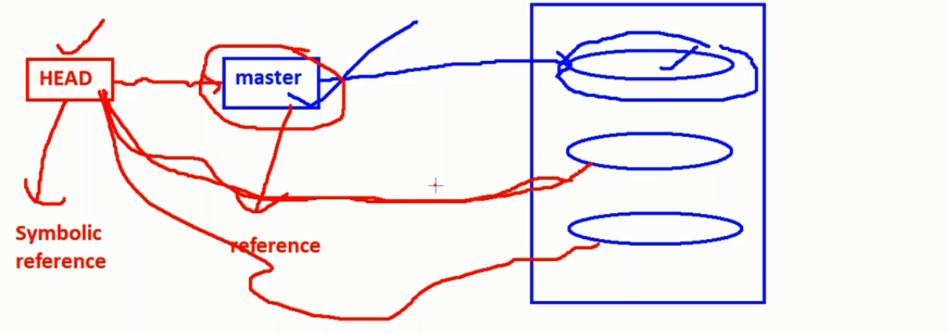
* 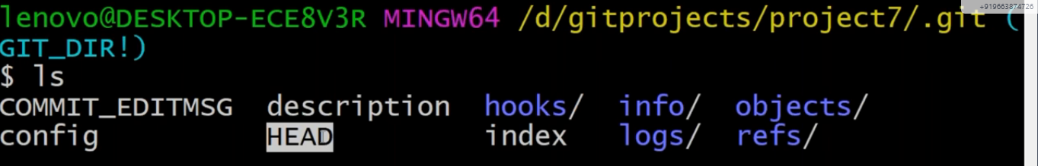
* 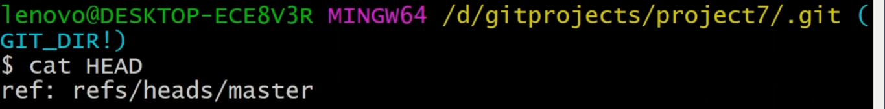
* To show in one line(compressed):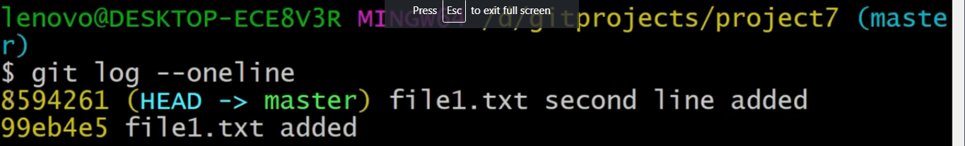
* 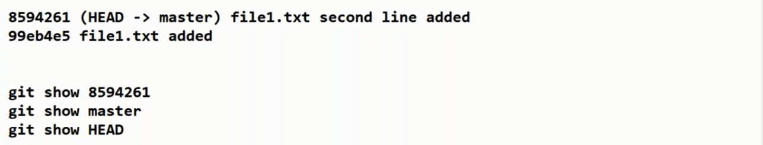
* Let us check how correct these are in terms of references:
* 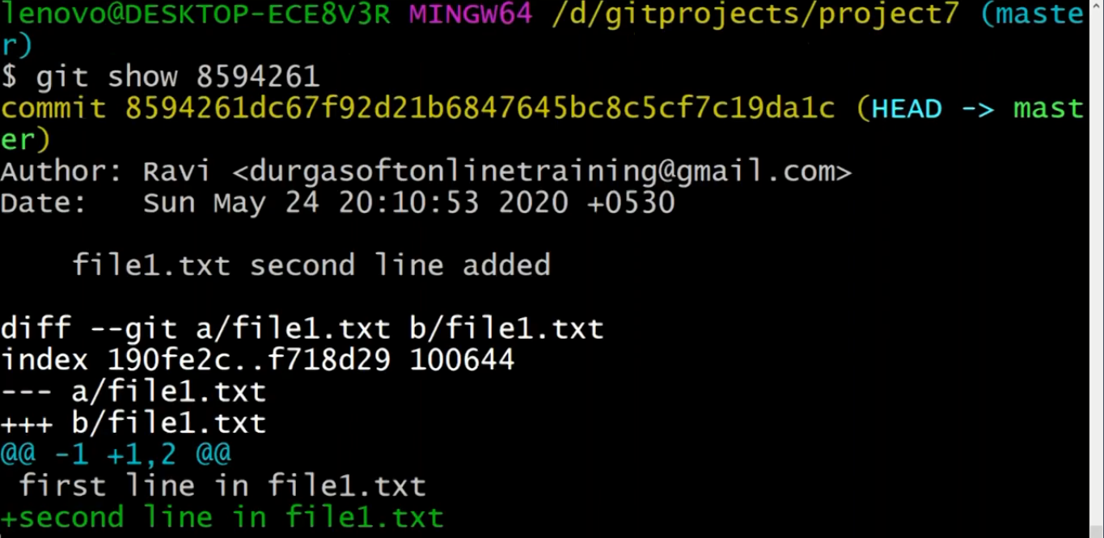
* 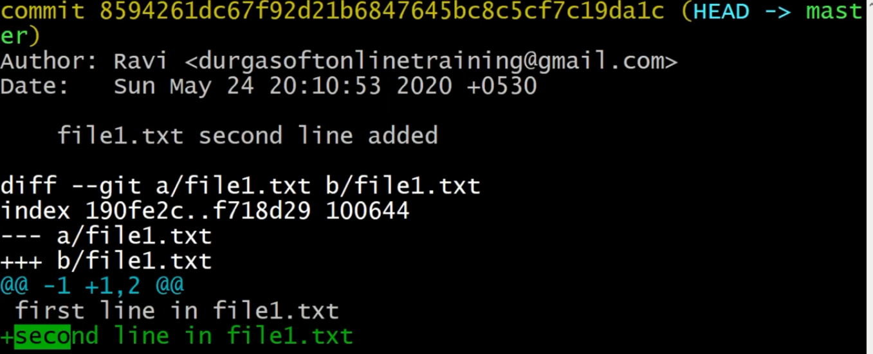
* 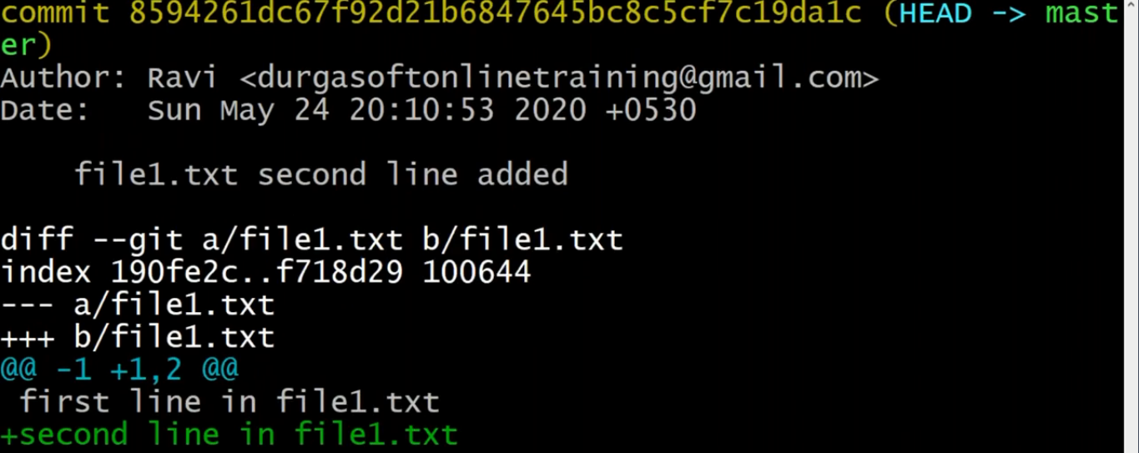
* **First commit(not the current commit):** HEAD~1 is a special commit identifier in git; it stands for the previous commit (not the one we just made, but the one before that).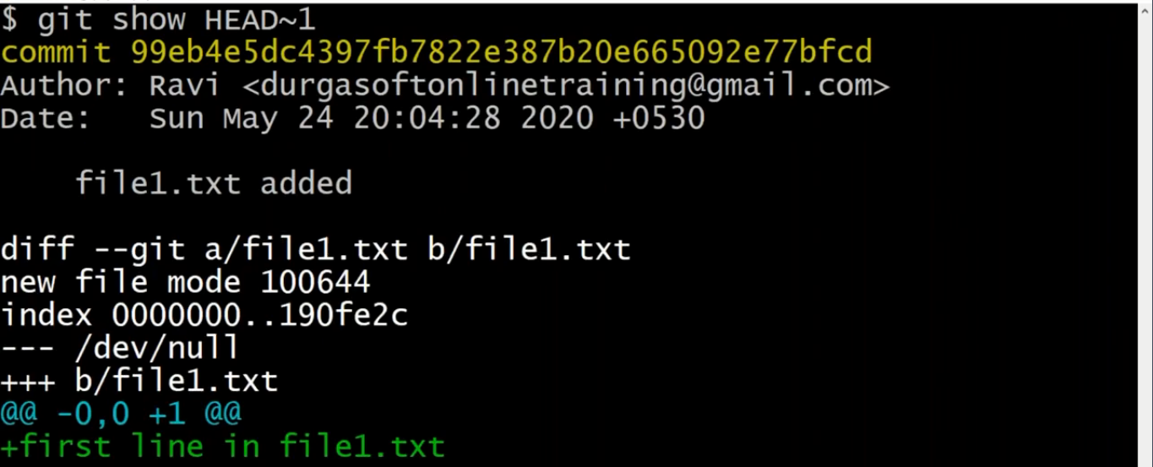
* Third commit:
* **HEAD**~**2** (or **HEAD**^^) refers to the commit that is two levels of ancestry up/above the current commit (the **HEAD**) in the hierarchy, meaning the **HEAD's** grandparent commit. **HEAD**^**2**, on the other hand, refers NOT to the first parent's second parent's commit, but simply to the second parent's commit.
* 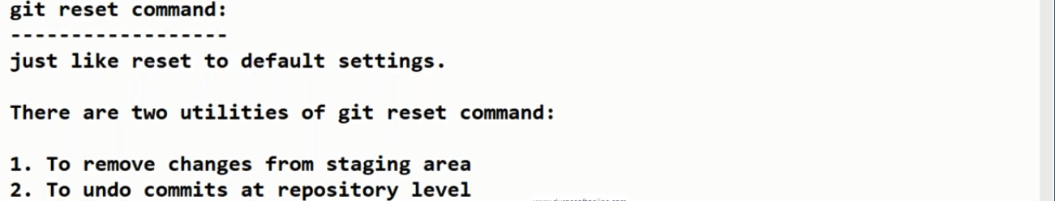
* 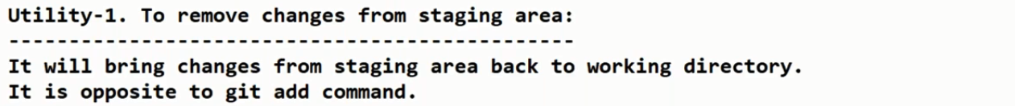
* 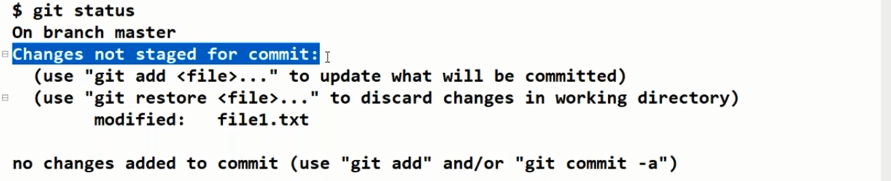
* 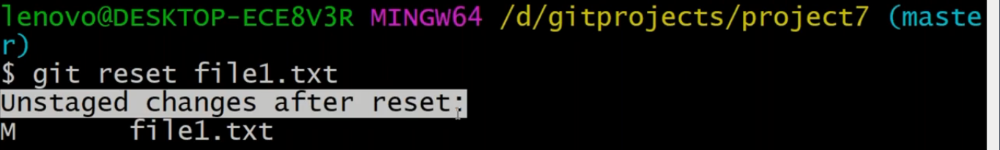
* 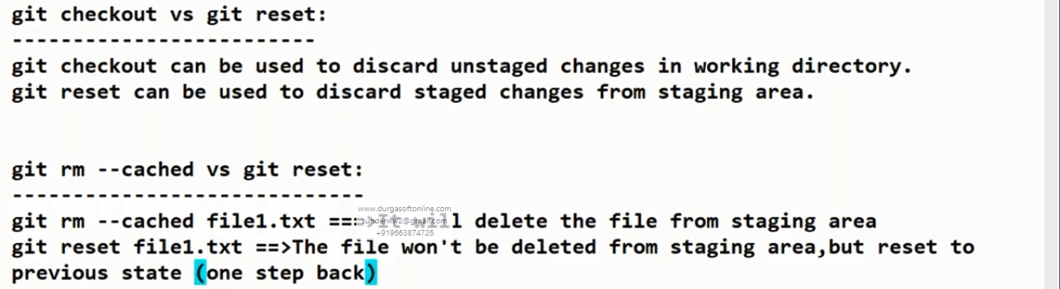
* 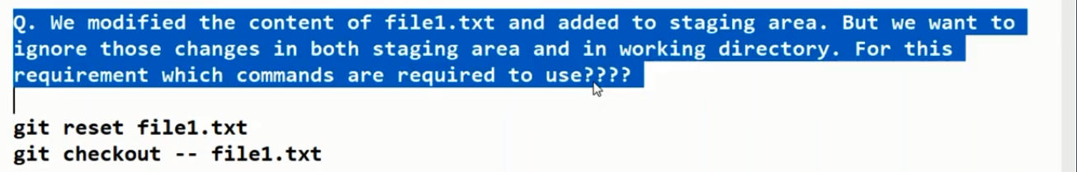
* 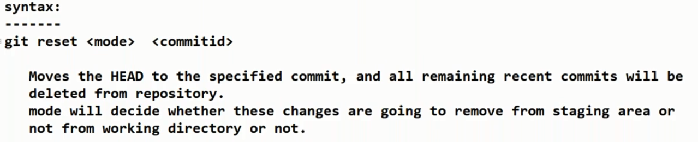
* 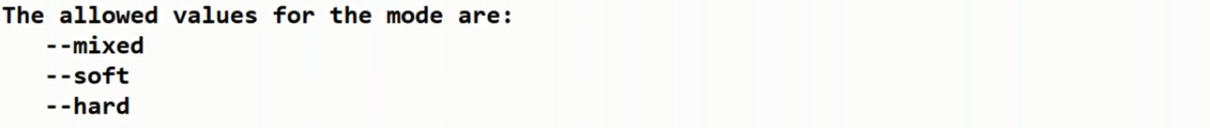
* 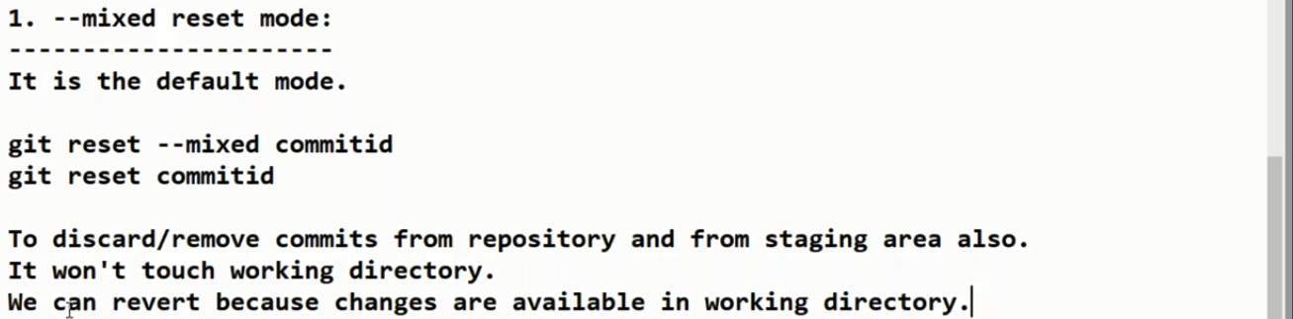
* It will be removed permanently:
* 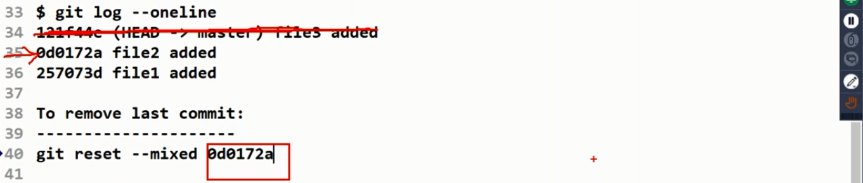
* 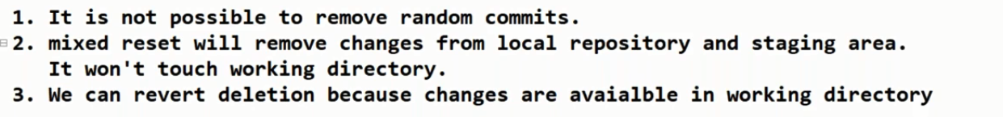
* 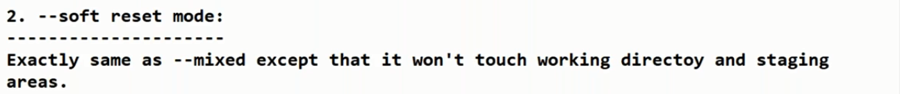
* 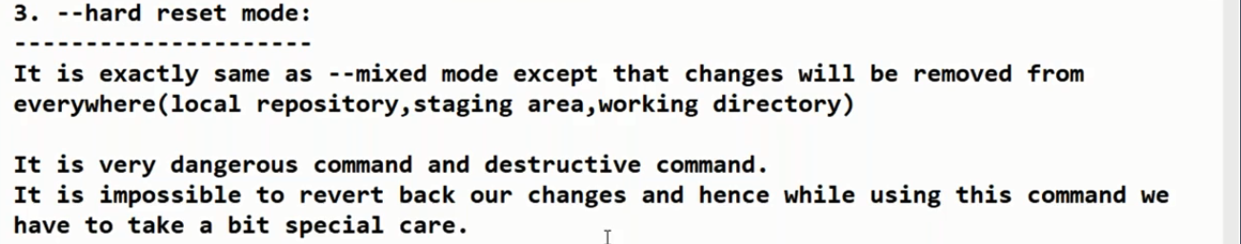
* 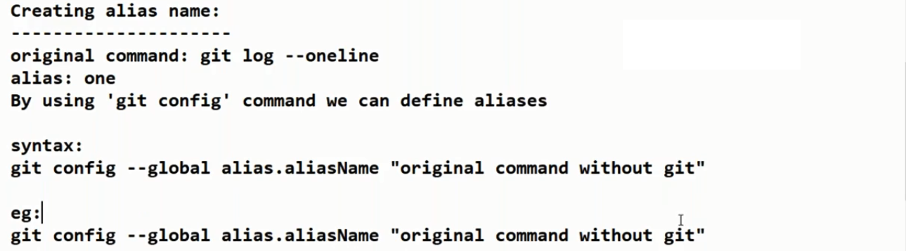
* 
* **How to ignore files except source files?**
* 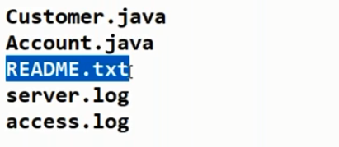
* README.TXT,server.log and access.log are not neccessay, we can ignore them.
* 
* Creation of those files: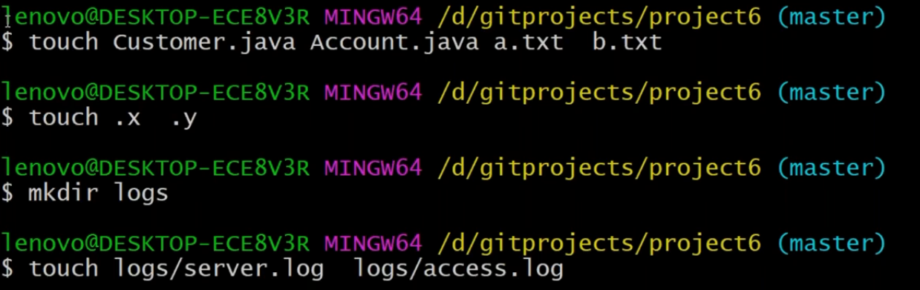
* 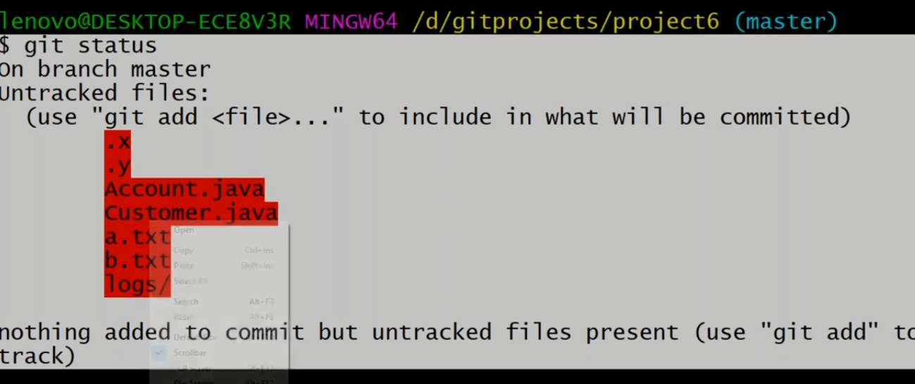
* 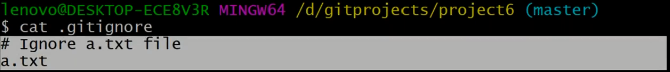
* Now the **a.txt** file is ignored.
* 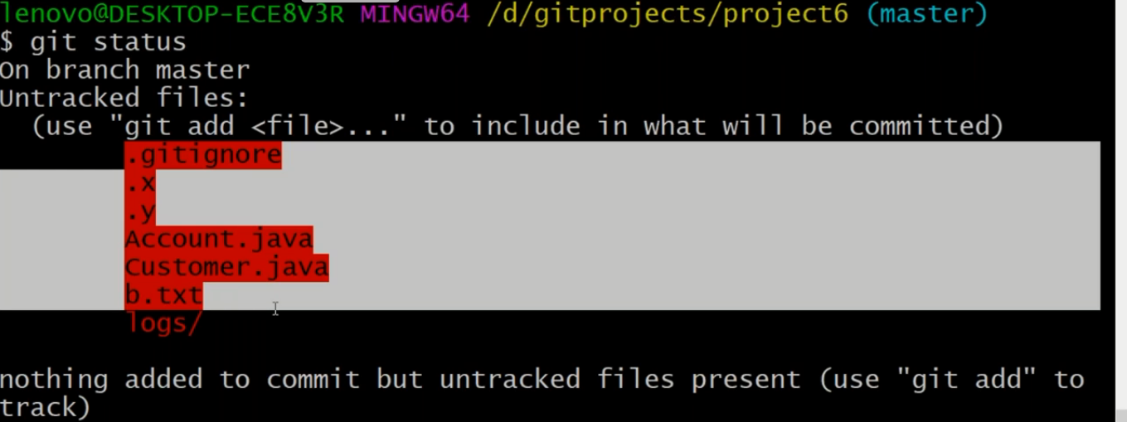
* 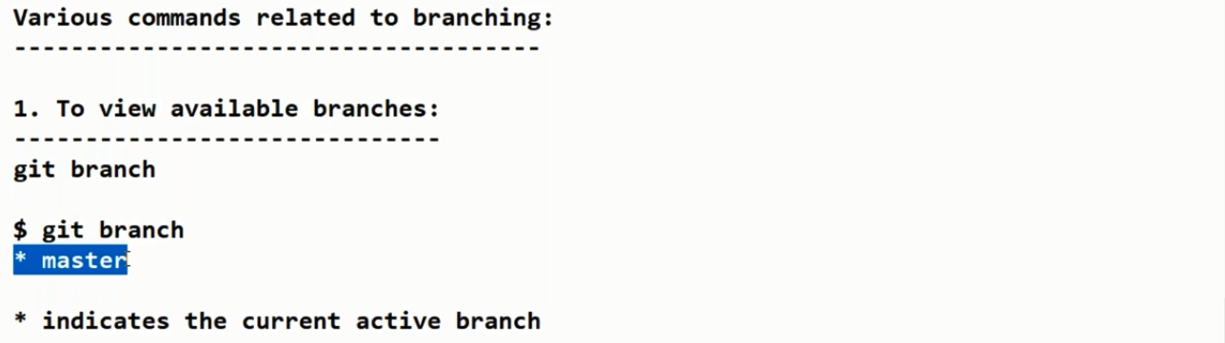
* 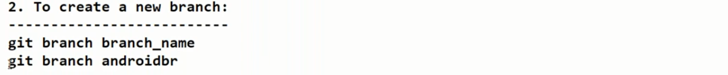
* 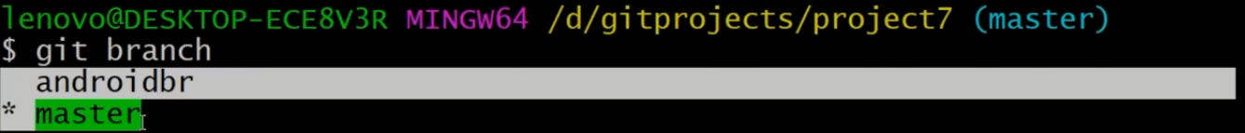
* 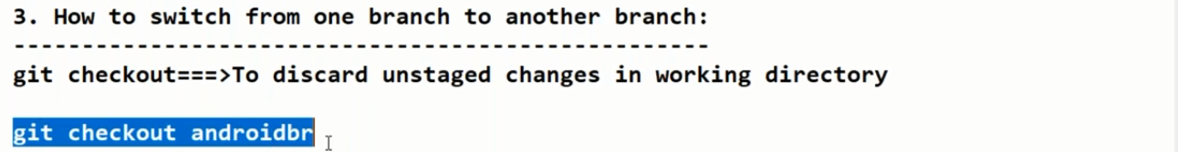
* 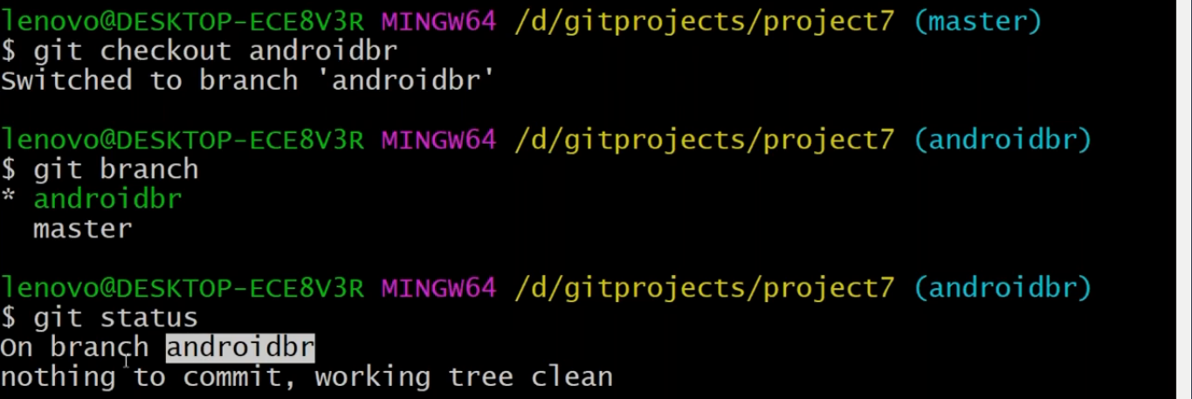
* 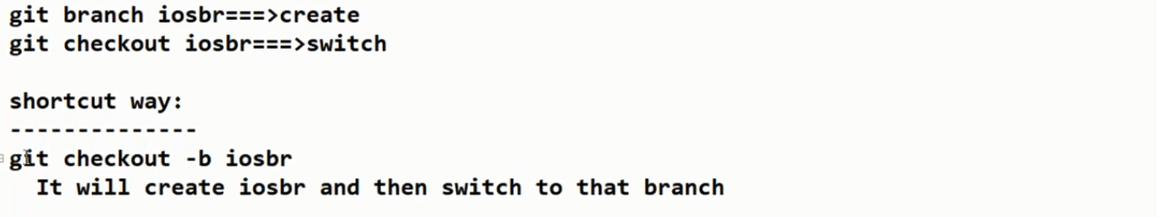
* 
* How to merge:
* **git merge branch-name(here branch name is branch)**
* 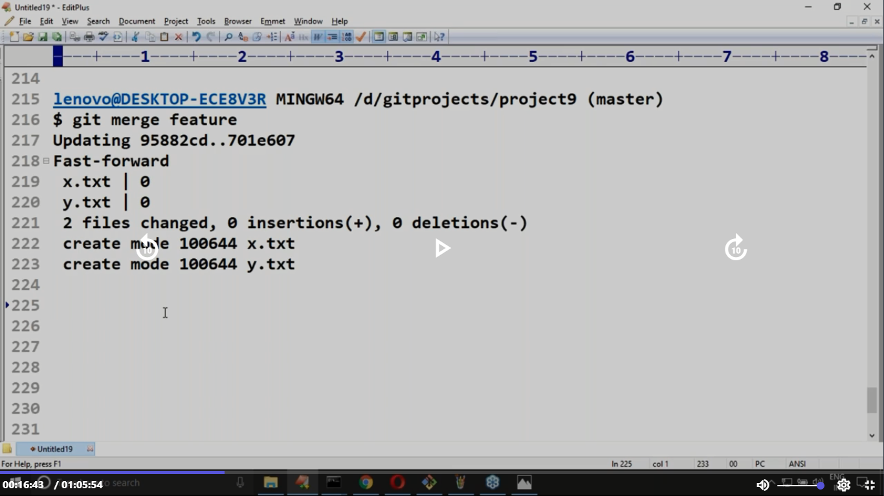
* 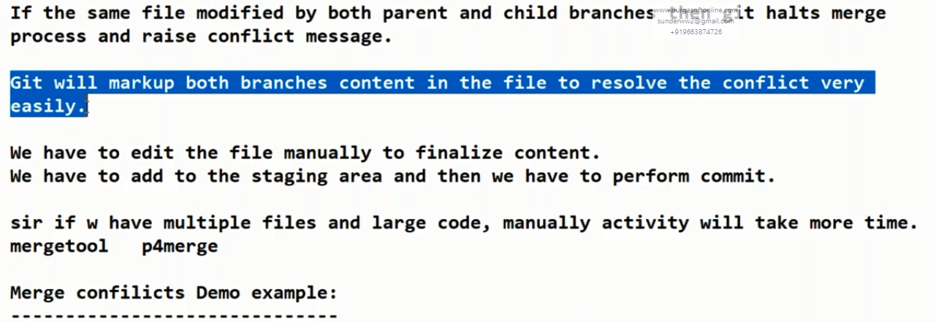
* 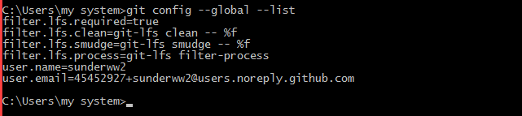
* git config --global --list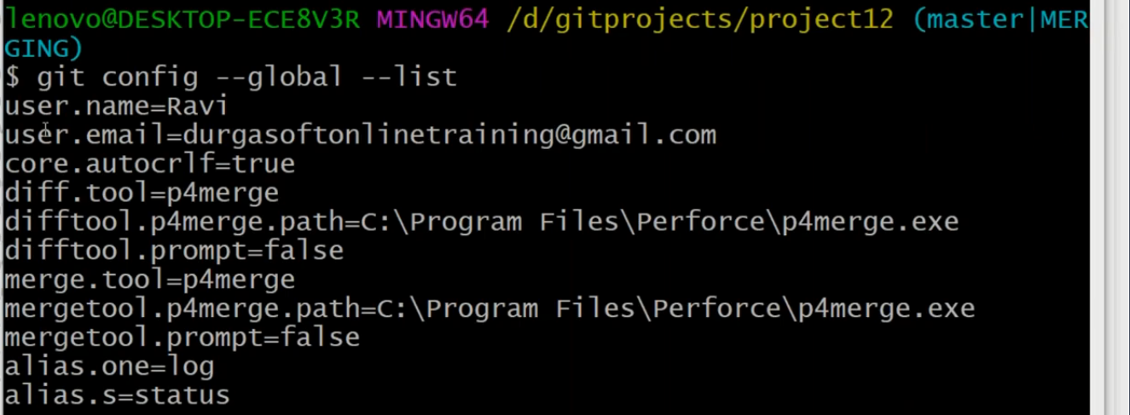
* 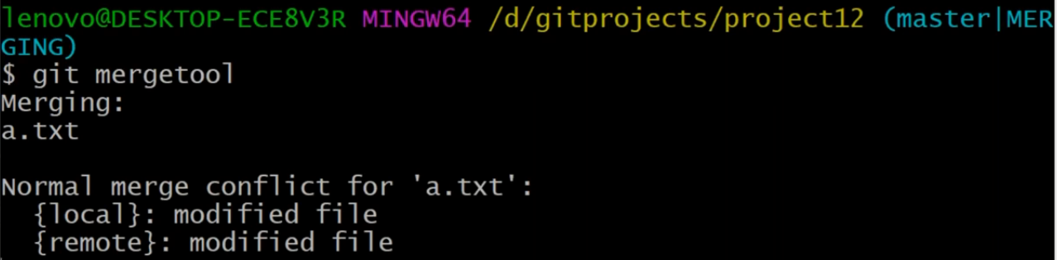
* Once you enter this command, it launches this: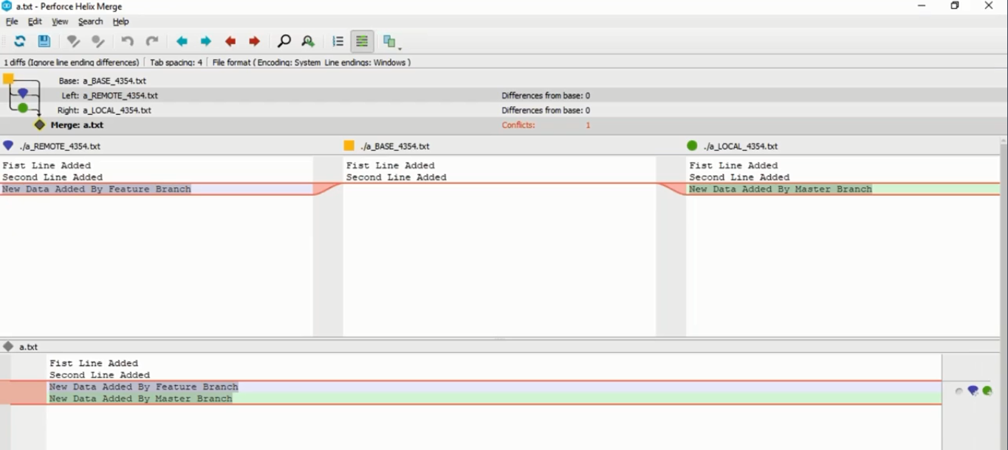
* 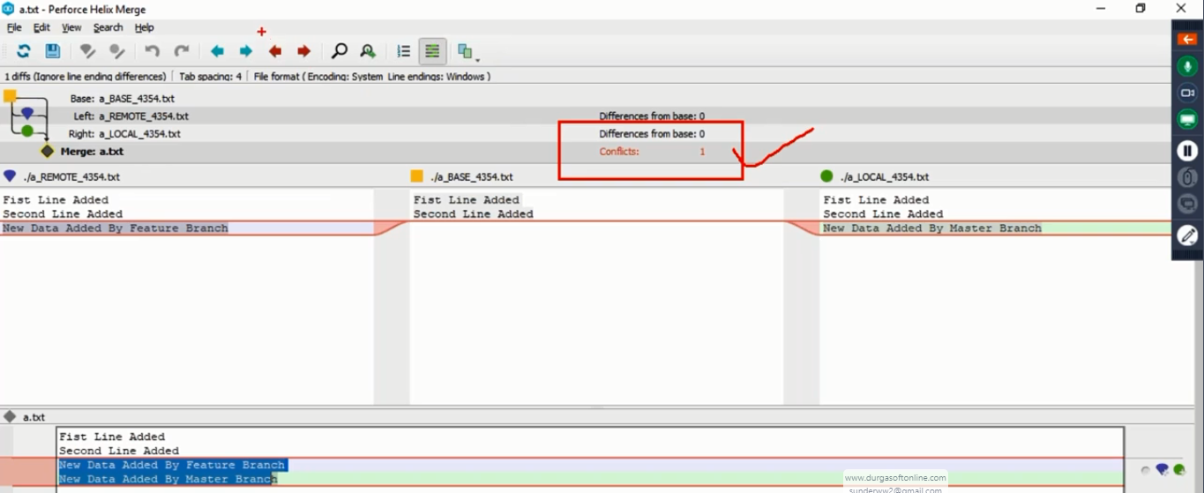
* You can decide what to keep and click on save button: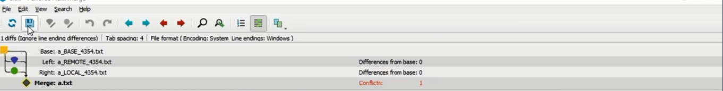
* 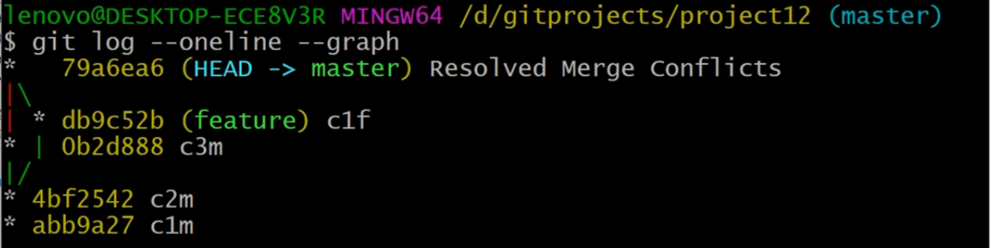
* Deletion of a branch: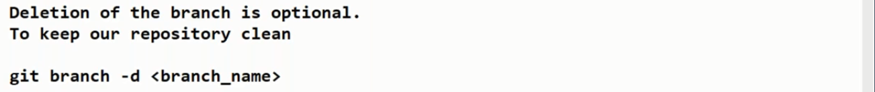



Now, I have made changes to the file:

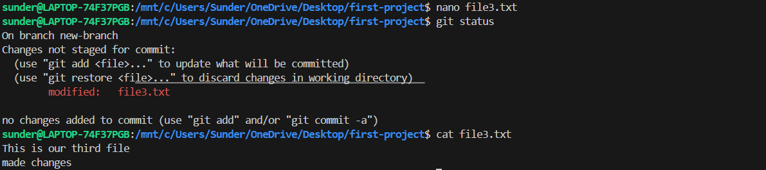

After committing the changes: 

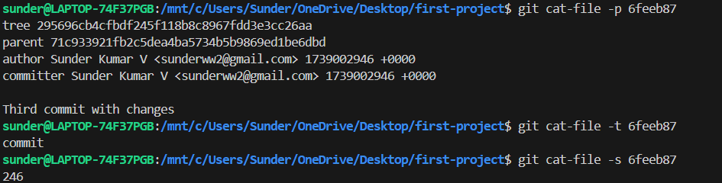

Now let us check the history of the commits: 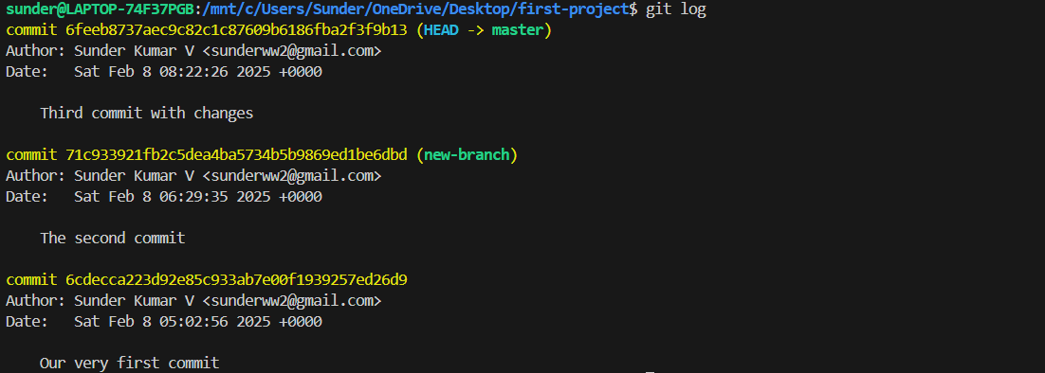

And see where HEAD is pointing now? 

Let us checkout an older commit and see what happens:

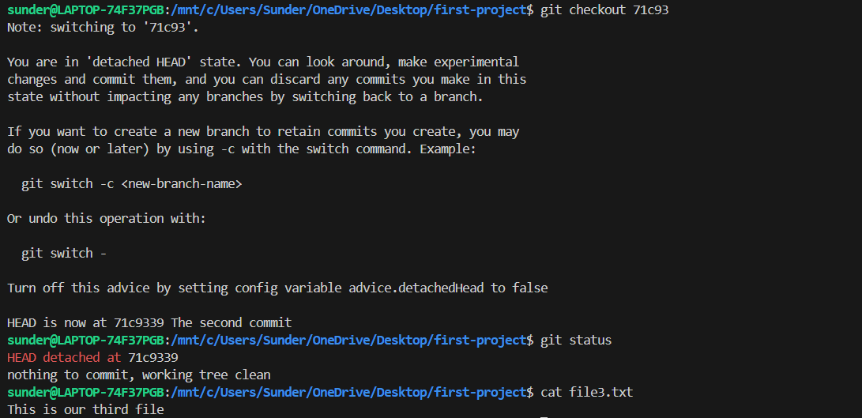

We see that file got reverted to it 2nd commit and that’s how HEAD is also pointing to the the older commit: 

Let me now go back to the latest commit: 



You can clone or download the contents of a remote repository by making use of the below command:

git clone **<Repository URL>**

If you want to clone a specific branch of the remote repository:

**git clone -b <Branch name> <Repository URL>**

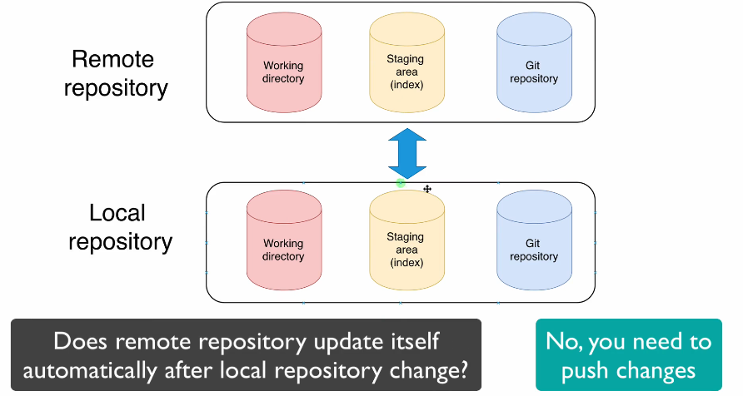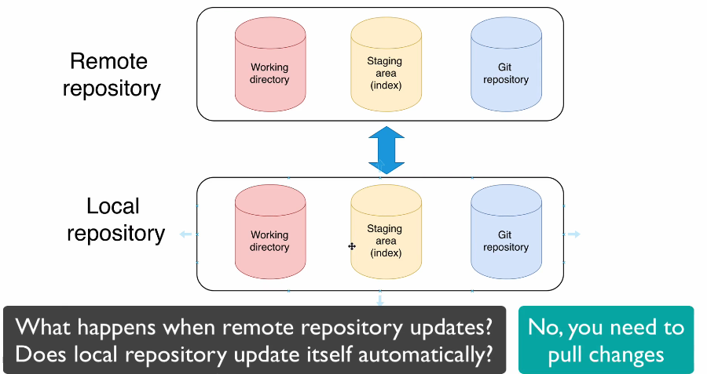





We do not manually merge branches via command line anymore since we do it on github or gitlab or bitbucket since it has to also go through a series of pipelines and then it has go through code review. It has become very obsolete.



We have discussed what is remote repository and what is local repository.And you know that such commands as git pull, git, push and git fetch are used for interaction with remote repository.

And in one of the previous lectures we have cloned remote repository from our own GitHub account to our local computers. And now let me answer the question how actually our local repository is connected to remote repository.

By default, when you clone a remote repository to your local repository, git automatically creates binding between remote repository and local repository and it creates default remote repository for your local repository and default name of remote repository is origin like so. 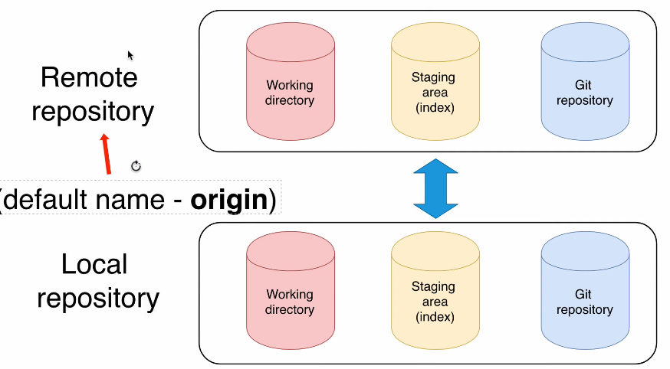You can actually connect your local repository to multiple remote repositories. And in such case, every remote repository will have different name.

And when you perform for example, push, pull or fetch operations, you actually choose which remote repository you want to interact with. By default, if you for example, just write command git pull u will pull from origin from defaultremote repository.Let's now actually jump into command line and verify how list of remote repositories looks like there.

Okay, let's go to terminal and let's verify list of remote repositories here in cloned repository: 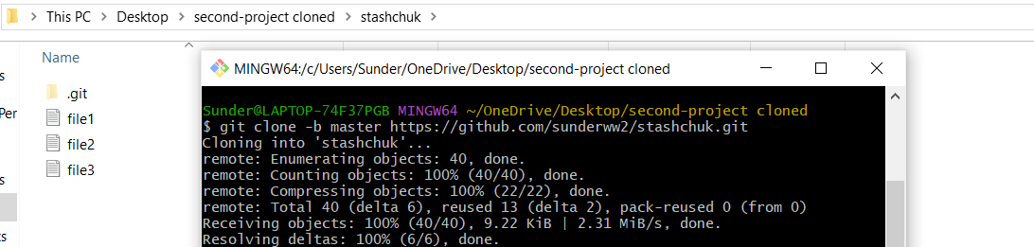 And now using command git remote, you are able to list all remote servers for your local git repositories.Let's press enter and here you will see default name of remote server, origin: 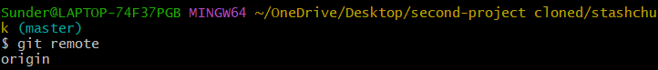

You can add here -v option and in such case you will see two lines of origin: 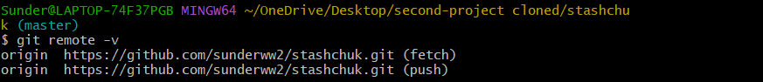Then URL of your remote repository and in parentheses fetch.Let me make it a little bit smaller like so and next line will be the same with same URL.But here in parentheses you will see push.And that means that the same URL will be used for fetch and push commands.

**You will not be able to list up all the branches of the remote repositories,** ** that's because by default, git branch command lists only your local branches :** 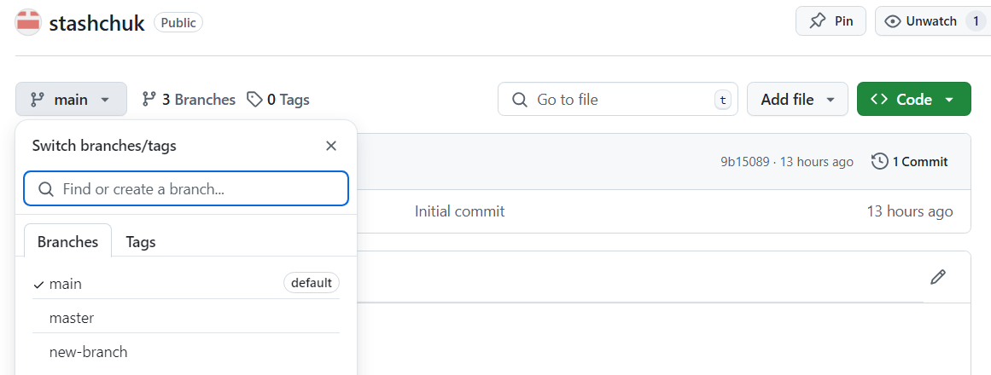

**These are the remote branches.**

**Let us see how to list all (Local + Remote) branches and work around them:**

How to list all branches of local with slightly **more information?**

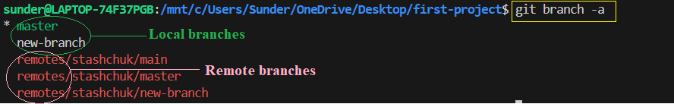

The prefix ‘remotes’ means that these are all remote branches, followed by name of the git server ‘stashchuk’. Since I , Sunder created the **stashchuk** server, it shows it that way. In most cases it will be **origin.**

How to list all **remote only** branches**?**

**git branch -r**

Hence,

|  |  |
| --- | --- |
| git branch | List all local branches(By default, lists only local) |
| git branch -r | List all remote branches |

With some more information than previous?

git branch -vv





Tracking branch is your local branch that is connected to specific remote branch.

By default, when you clone any remote repository, GIT creates only one tracking branch locally in your local git repository. And name of this branch matches default name of the branch in remote git repository. What default name?

And if I'll go to our repository to branches list here you'll see that master branch is tagged as default branch and you actually can change your default branch by clicking on this button Change default branch and choose your new default branch. 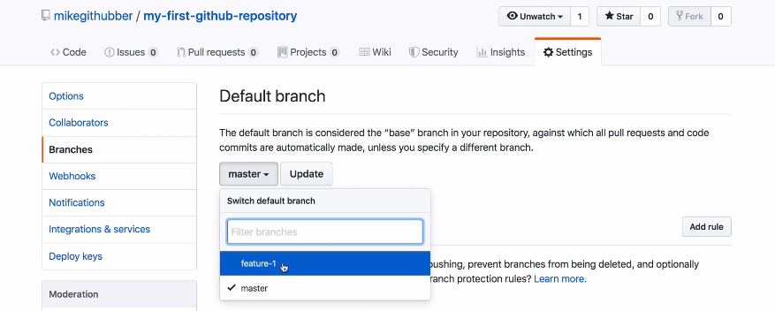



Simply, checking out like this wont help, we would be checking-out the local branch instead. So follow this step:

git checkout --track origin/new-branch

Or If the branch doesn’t exist locally then :

git fetch origin

git checkout -b new-branch origin/new-branch

Let us see what happens when we checkout a new branch with different content than ours: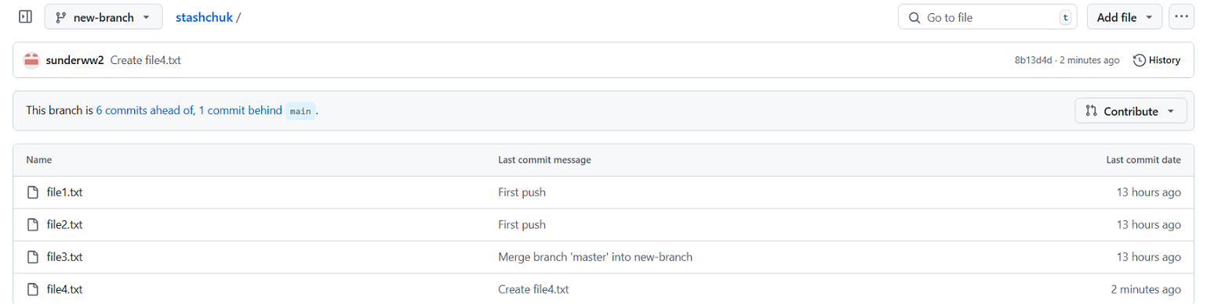

But locally we have only 3 files: 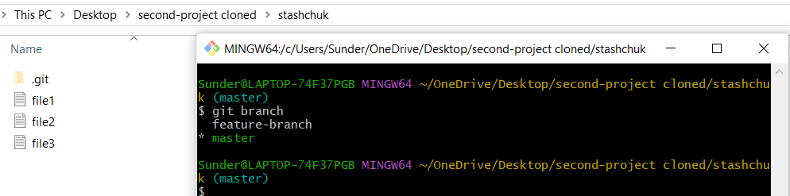

Let us check out the remote branch :

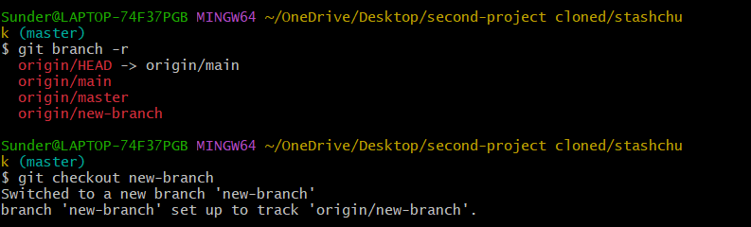

There wont be any changes to the content since if we want them and we have any important work in our plate , we must commit the changes and then pull the changes:

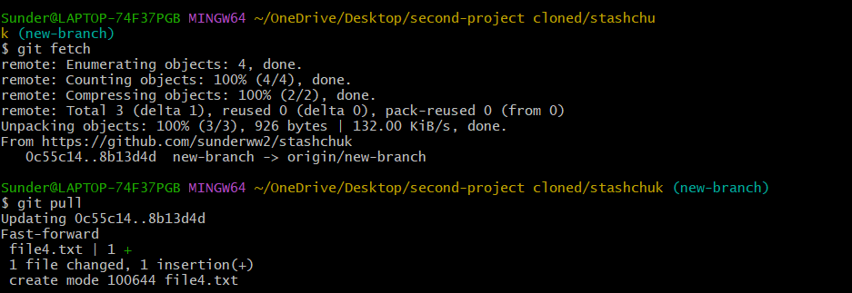

Now, you can see that the files are reflected: 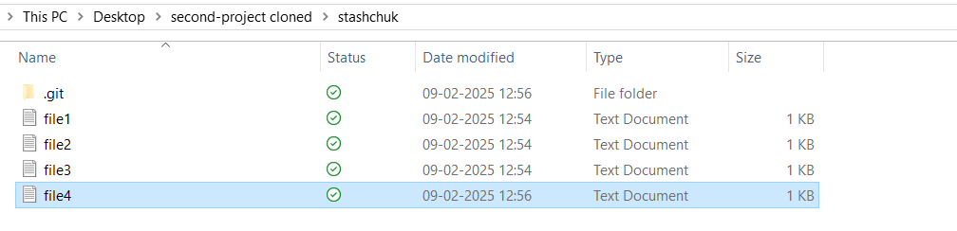

**GIT STASH vs GIT COMMIT**

Both stash and commit commands help in saving work but they serve different purposes.

Git stash is useful in purposes when:

* Want to switch branches without committing:

Suppose you're working on **feature-branch** but suddenly need to switch to main to fix a bug. You can’t switch because of uncommitted changes. Instead of committing unfinished work, just stash it:

* Don’t Want to Create Unnecessary Commits:

If you're experimenting or debugging and don’t want to clutter history with temporary commits, stash is ideal:

* Need to Save Changes Without Committing:

If you’re halfway through coding and need to pull the latest updates, but don’t want to commit yet:

Working of git stash :

I am on a feature-branch working on file3.txt with work like this:

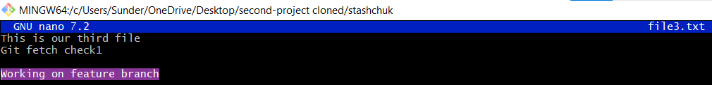

And suddenly I am asked to work on an emergency on new-branch. Some user added a new file and is having an error: 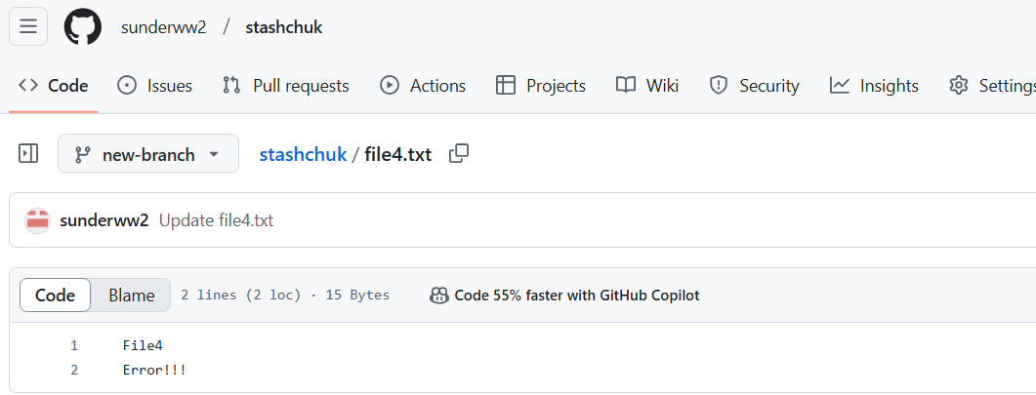

So, back in our current local branch, I have some uncommitted work. Hence I should stash them: 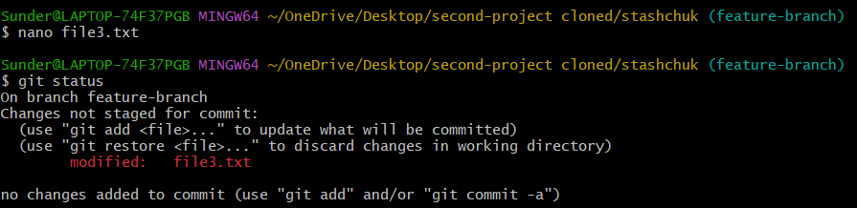

Now I stash my uncommitted work so as to not lose them: 

One can observe that the stashed change was assigned a commit-id: dc86f5b

This can also be seen from history of commits using git log

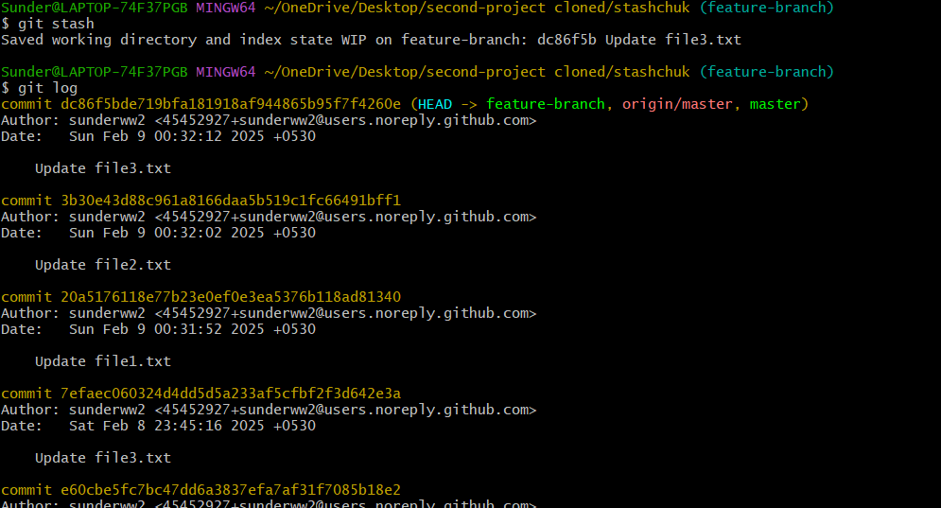

Hence in this case , it is similar to git commit where a commit id is generated and we can checkout the commit-id later after the fix in both cases. In case of stash, after we come back , we need to just use **git stash pop** whereas in the case of regular commit, we need to manually checkout the commit-id from git log

Let us just fix the issue and come back:

In this case, we have two new-branch each in local and remote: 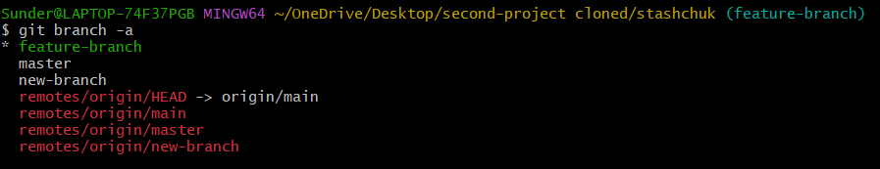

Simply, checking out like this wont help, we would be checking-out the local branch instead. So follow this step:

git checkout --track origin/new-branch

Or If the branch doesn’t exist locally then :

git fetch origin

git checkout -b new-branch origin/new-branch

After that verify that the branch you are on is indeed the remote branch using git branch -vv

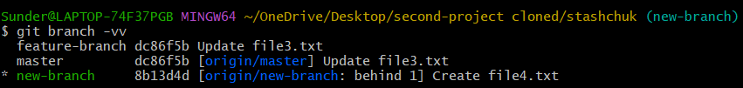

Nevertheless, **we have to pull the fresh changes.** Also, here it evidently says that we are behind by 1 file.

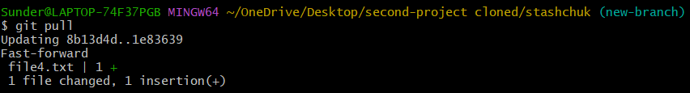

Let us fix it: 

 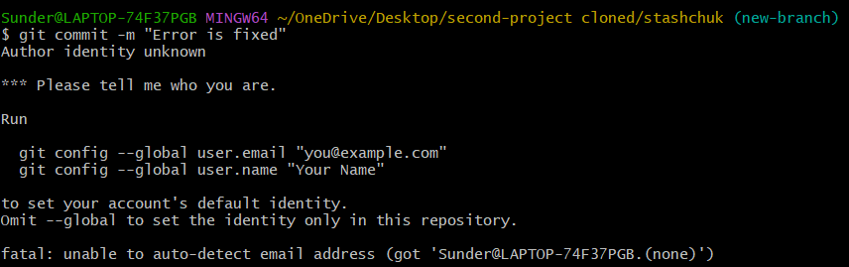 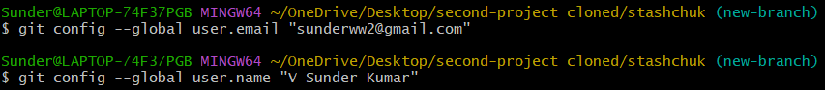 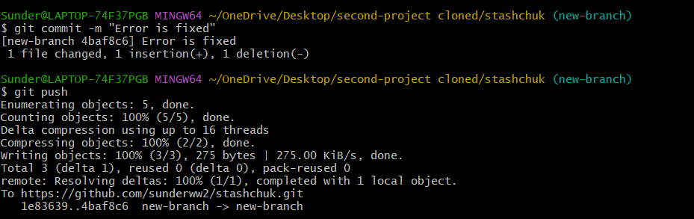

**Pushed changes:**

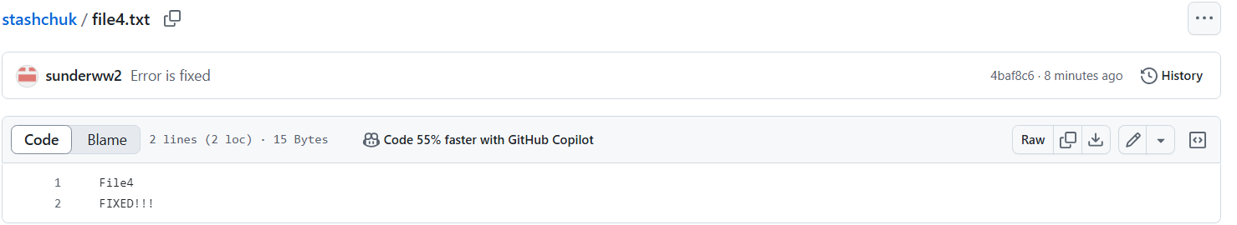

Let us now come back to our feature-branch:

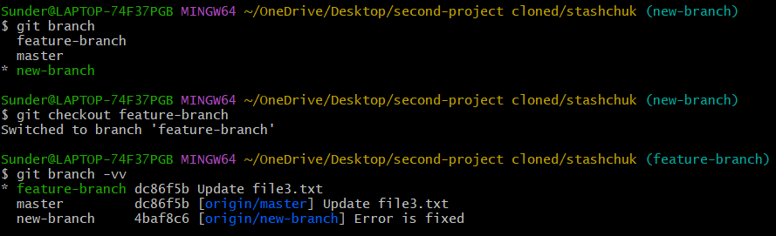

Okay, we are on our local now. We cant do git pull since it is not a remote: 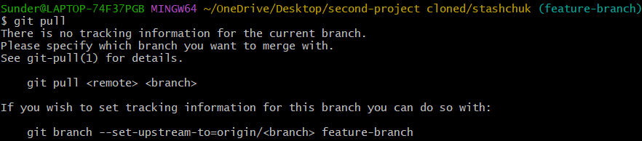

All you have to do is this:

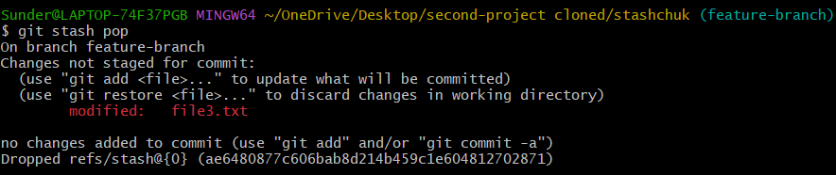

And the changes get reflected instantly. No need to pull or do other crap. It is back to original form: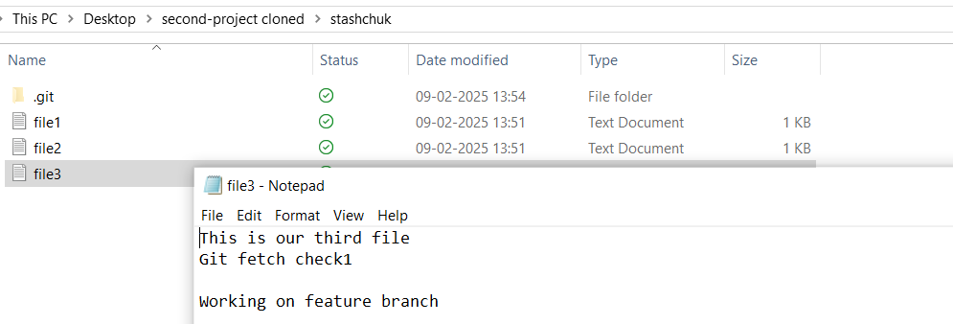

That’s it. We are now ready to add this to staging area and push the change. The only disadvantage of git stash is that we can only use last commit unlike the the regular commit where we can navigate to any commit-id and check it out. Let us see that as well:

Again let us assume that we have some error in the remote branch: 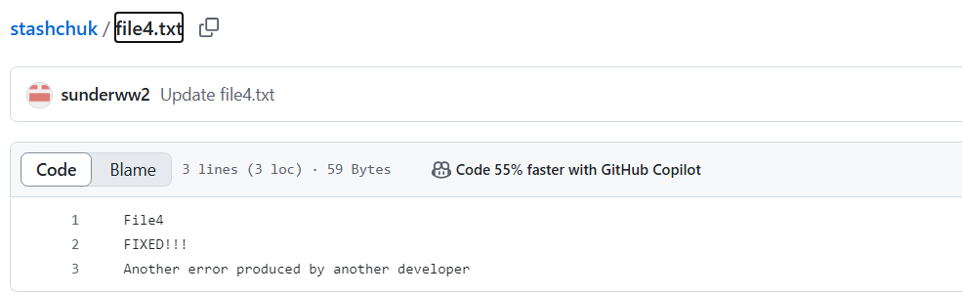

And we are working on the local feature-branch: 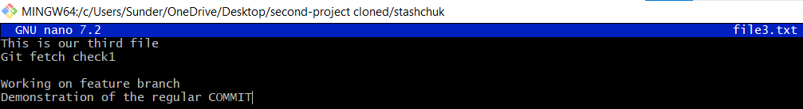

So we COMMIT the changes and hop on to the remote, new-branch: 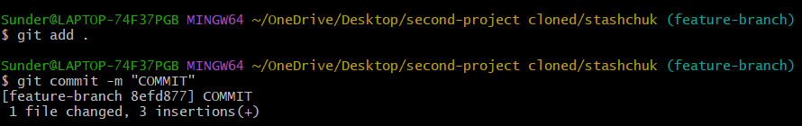

After checkout, we need to pull the changes:

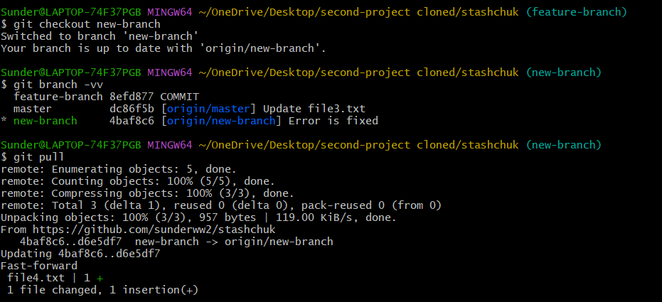

Now after fixing: 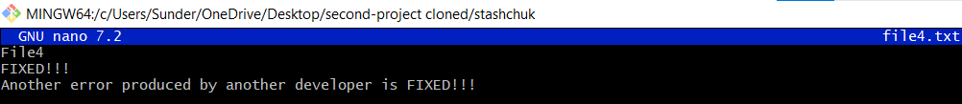

Let us push it: 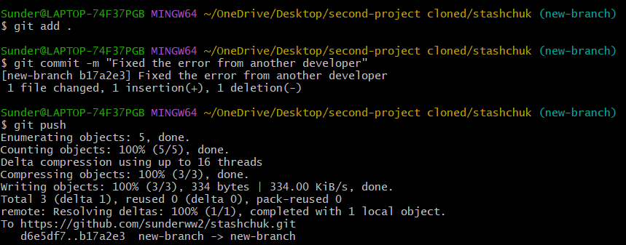

Changes reflected: 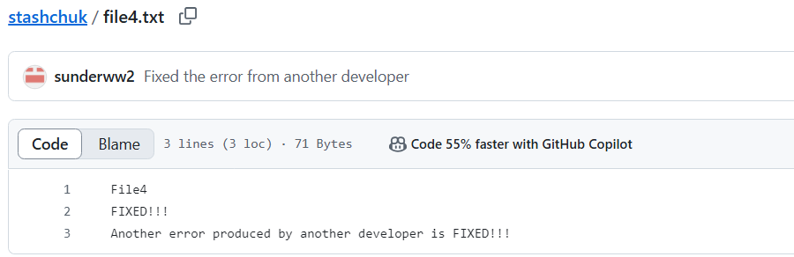

Now let us come back to feature-branch: 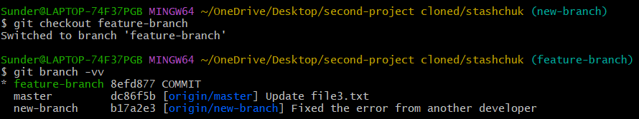

Now this time, let us see if we can use git stash pop to retrieve our last commit:



Hence, we can’t use git stash pop even though we want to reteieve the last commit.

So only manual checkout of past commit ids would work here: 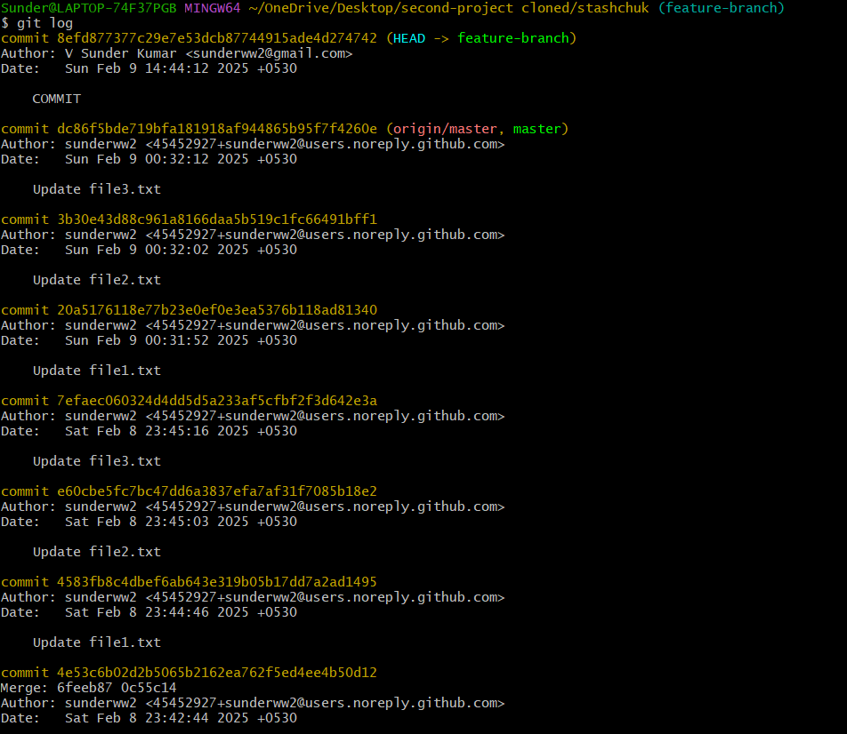

Let me go back to an older commit id: 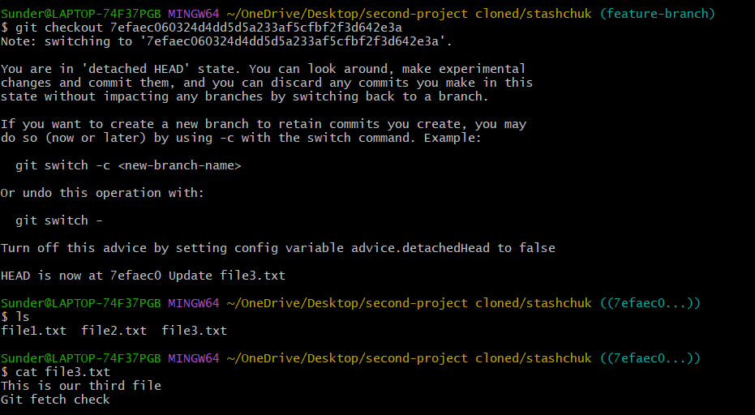

But if we have to push this change, we have to follow some unique steps otherwise this is what we get: 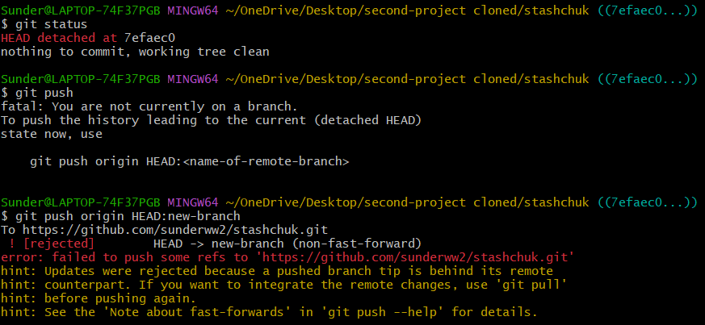

Correct. We are not on a branch. We cant push from a commit id. It has to be a branch. Hence, WE MUST CREATE A BRANCH:

1. Create a branch from the old commit:

git checkout -b "old-commit"

1. Push it to the remote repository:

git push origin old-commit

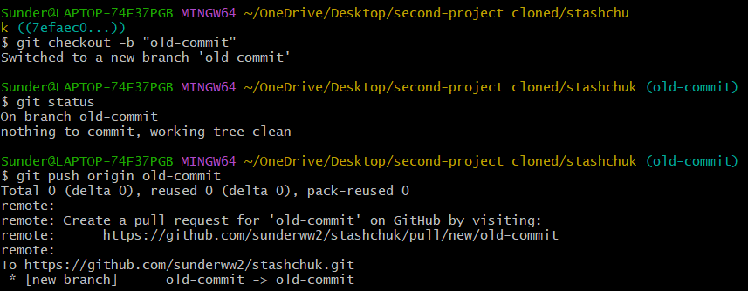

There are many other ways. But, let us not make it more confusing.



Rebase helps provide a better GIT workflow as opposed to merge.

The goal of both merging and rebasing is to take commits from a feature branch and put them on to a master branch or any other branch. Let's say I have a graph that looks like this:

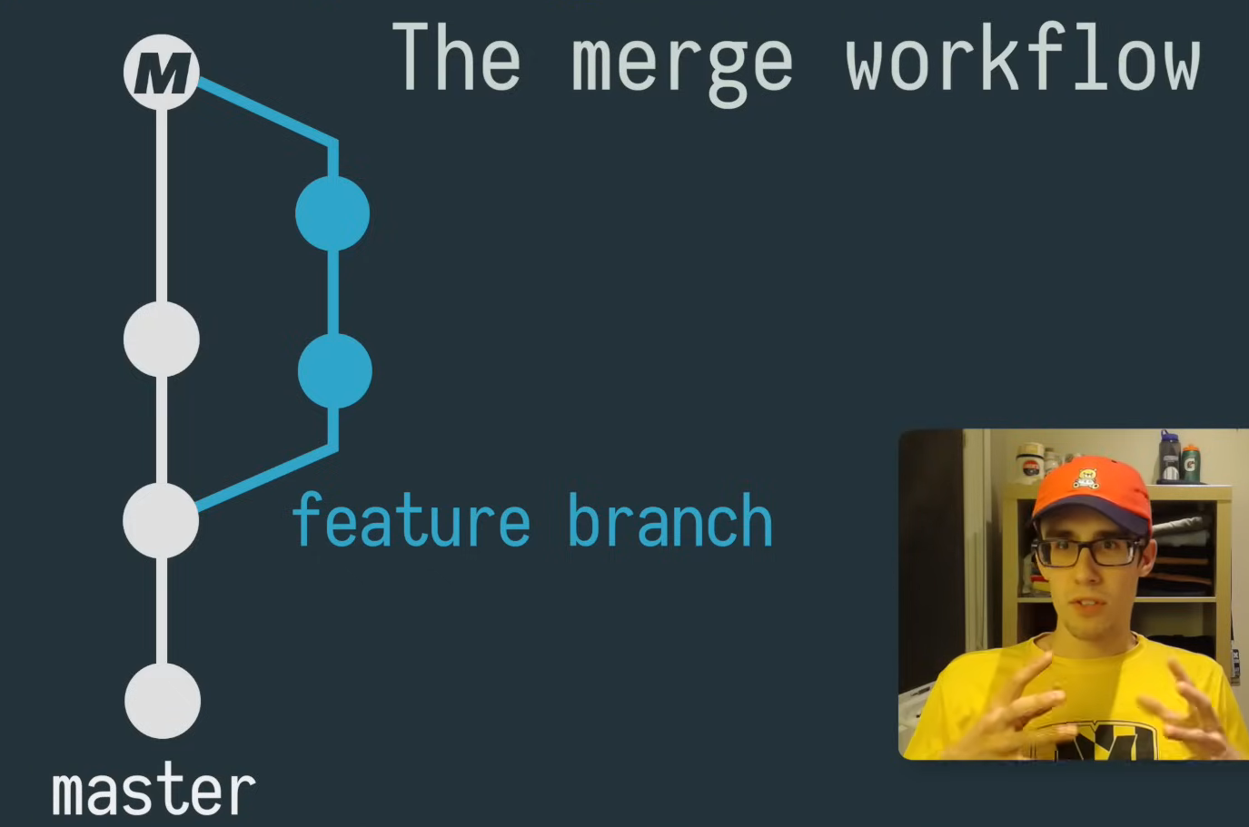

As you can see, I split off my feature branch and I commit two of master(two white balls) and I've done a bit of work on my feature branch with those two commits(two blue balls) there.

Now when I want to merge those two changes, back onto my master branch I'm gonna run a

git merge and this will take all of my feature branch changes and all the changes from both of those commits(both blue and white balls) and stuffs them into one merge commit.

And then put that merge commit on master . Your graph might look something like this and if you're working on team with other developers you can imagine that this could kind of get gross looking : 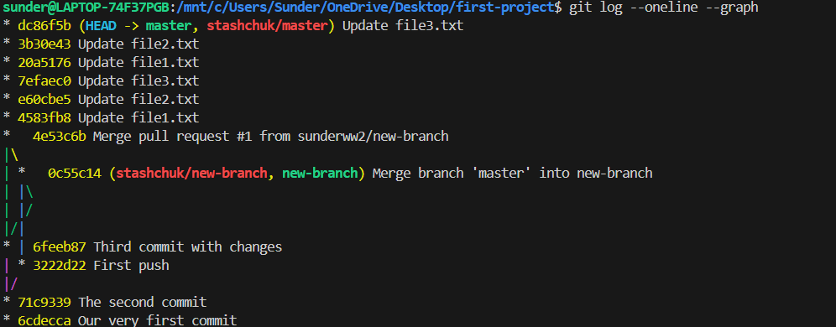 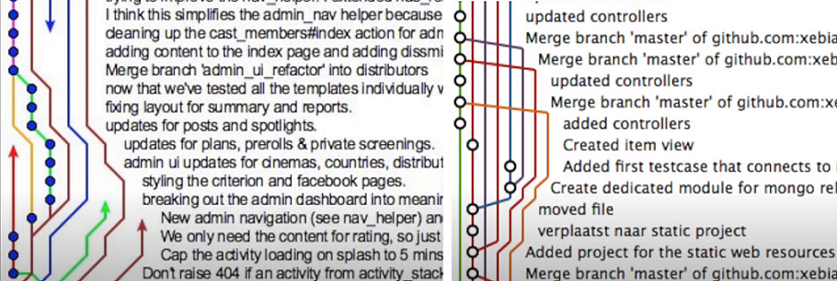 Also where you have a bunch of people working on different feature branches and they've been pushing changes and stuff like that so this is a little bit gross to look at it's confusing to trace and so this is where rebase is gonna help us out: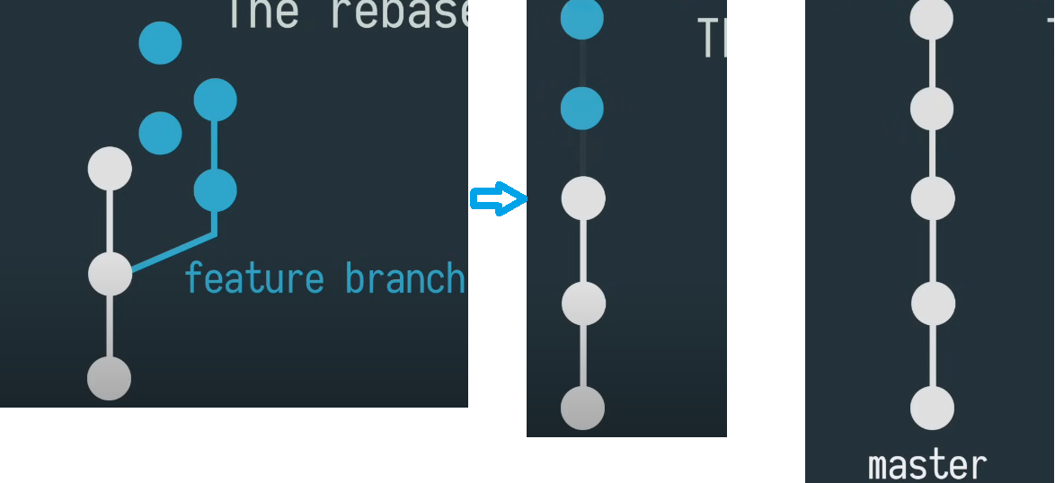

When we run our rebase, what you get with this approach is a nice clean straight line graph with all of your commits laid out nicely in a row it makes it really easy to trace what commits went where and as if you can imagine if you're on a team with a lot of developers all the commits are still in a row so it's really easy to follow even if you have a bunch of people working on the same project at the same time at this point.

**Stage 1:**

When you first start development you want to make sure you always sync the remote master and make sure you have all the changes that your teammates have been has been doing on your local machine:

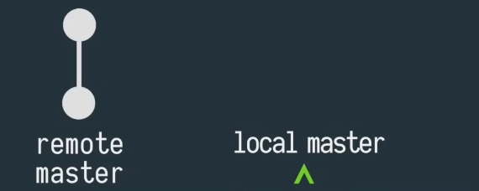

Stage 2:

You just want to run and get pull and make sure you up-to-date: 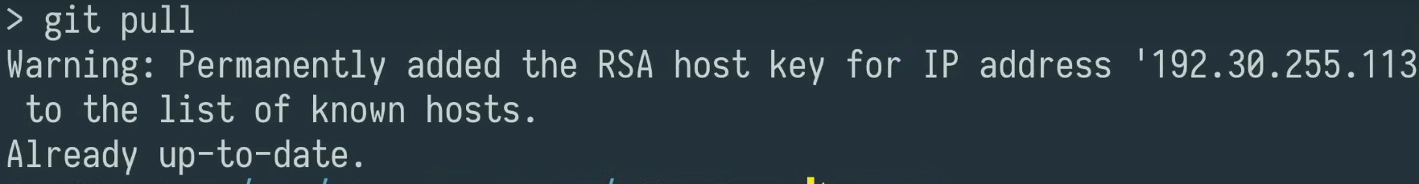

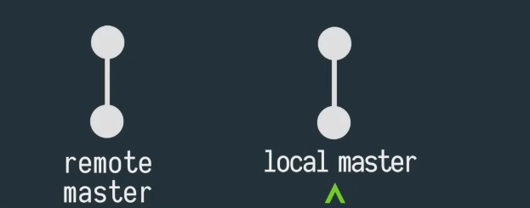

Stage 3:

When I start developing a feature you always want to **check out a new branch** so that all your commits in code can live on this branch without disrupting your master so we're just gonna get checkout

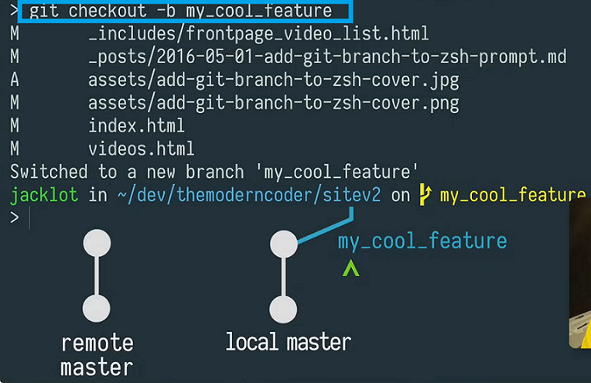

Step 4:

Now I am on a feature branch. As I am developing, I would be periodically adding files and committing: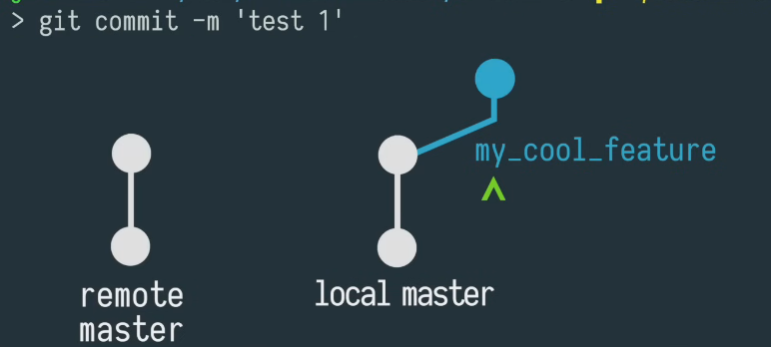

Add may be another commit: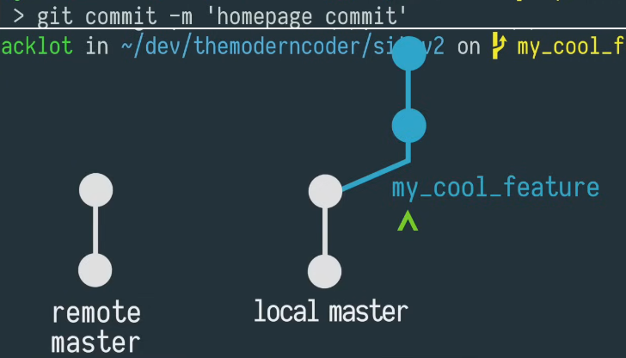

At this point, there are two commits. So as I'm making commits on my feature on my local machine I also have my fellow developers who are shipping features to our remote main or a master branch so this means that my development environment is kind of out of sync with the remote main. Hence, we will fix that when we merge.

Now that I'm now I'm done developing my feature and I want to merge it back into master so what I want to do is check out my local master: 

And then I want to git pull so what this will do is it will make sure that my local master is up-to-date with the remote master and any of the changes that my co-workers may have pushed in the meantime as you can see I'm one commit behind .

So now that I have all of my co-workers changes on my local master I want to make sure that my feature branch will jive with those changes.

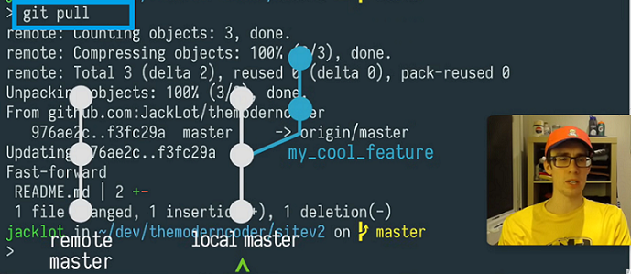

So what I want to do here is check out my feature branch



I'll do a rebase against my master: 

what this will do is it will re-anchor my feature branch against the latest changes and at this point GIT will let me know if I have any conflicts and if I do, I can take care of them and commit all my code to my feature branch in this case I have no conflicts so I'm good to go so now that my future branch doesn't have any conflicts with my up-to-date master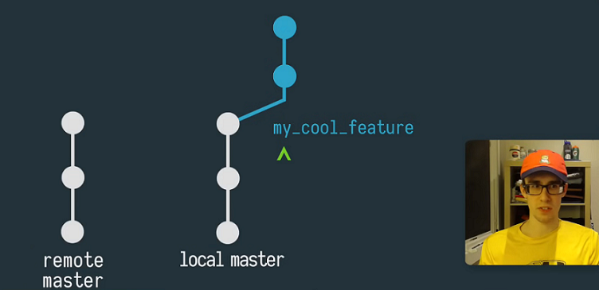

I'm gonna go ahead and check it out check out master and rebase master now against my feature branch. so at this point I should be good to go and all I have to do is a git push:

 

And what this will do is it will take those commits on my feature branch and replay them on top of my master branch so now my local main / my local master branch is nice and straight and ready to be pushed to production 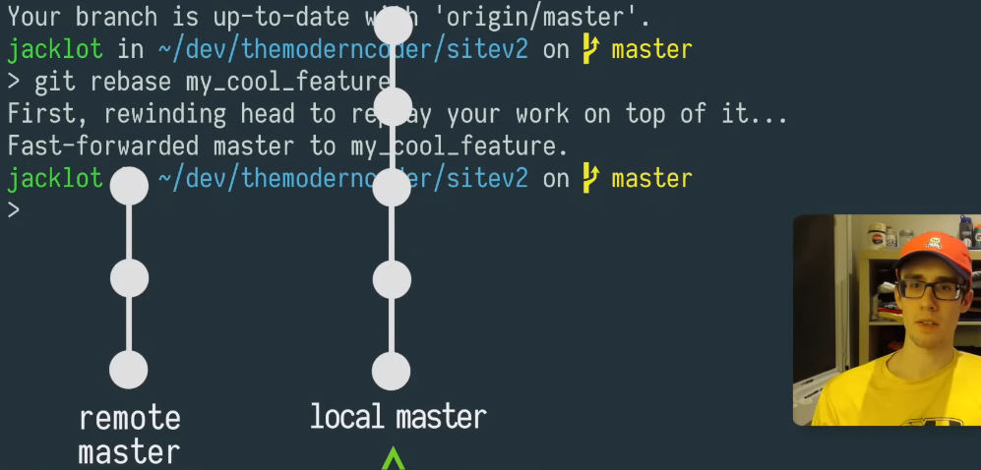

And now you have to do git push

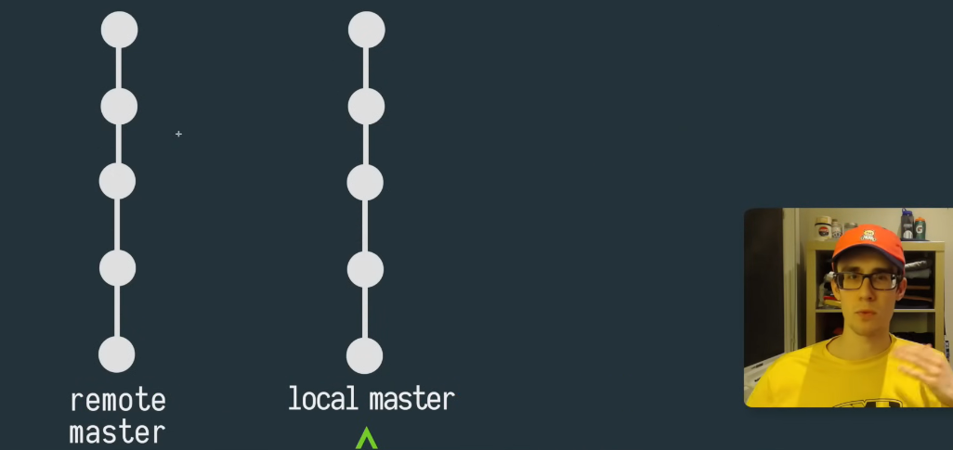

Hence, One of the worst stupid moves is to merge a PR with like 100 commits that all have messages like "fixing stuff , so totally you can fix this by placing all your commits into one single commit point.

